**ASSIGNMENT-01(WEEK-1)**

**ANIKET SAROJ**

**Bennett University**

**CT_CSI_SQ_4791**

**Database Used: AdventureWorks2022**

**1.** **SELECT * FROM SALES.vIndividualCustomer;**

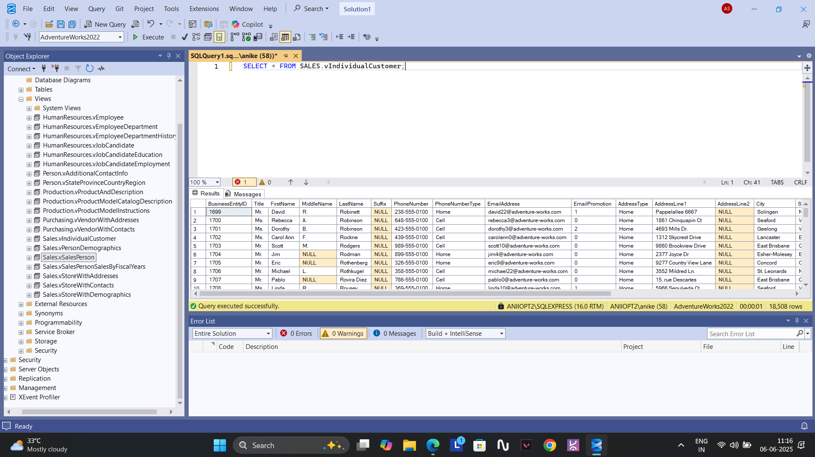

**2.** **SELECT * FROM SALES.vSalesPerson WHERE TerritoryGroup LIKE '%N';**

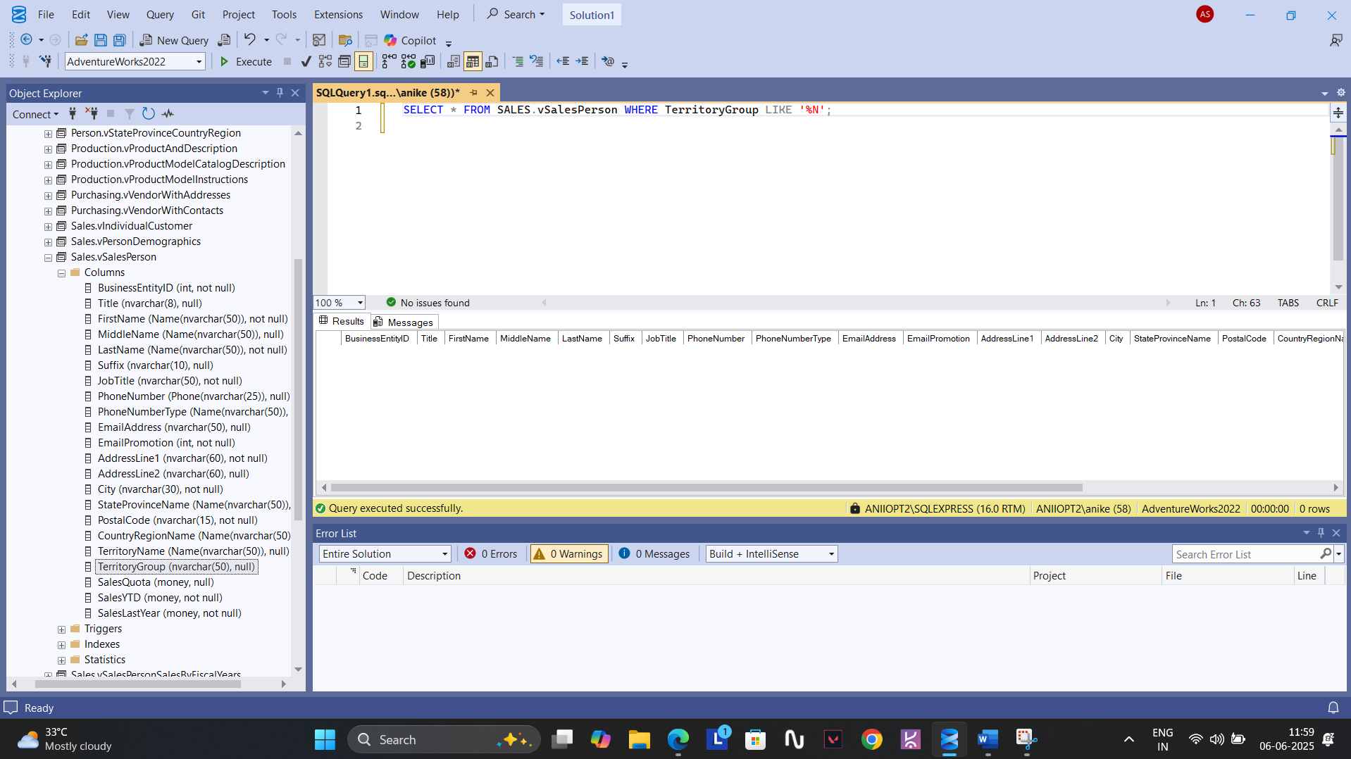

**3.** **SELECT * FROM SALES.Customer C JOIN PERSON.Address A ON C.CustomerID=A.AddressID WHERE A.City IN ('BERLIN','LONDON');**

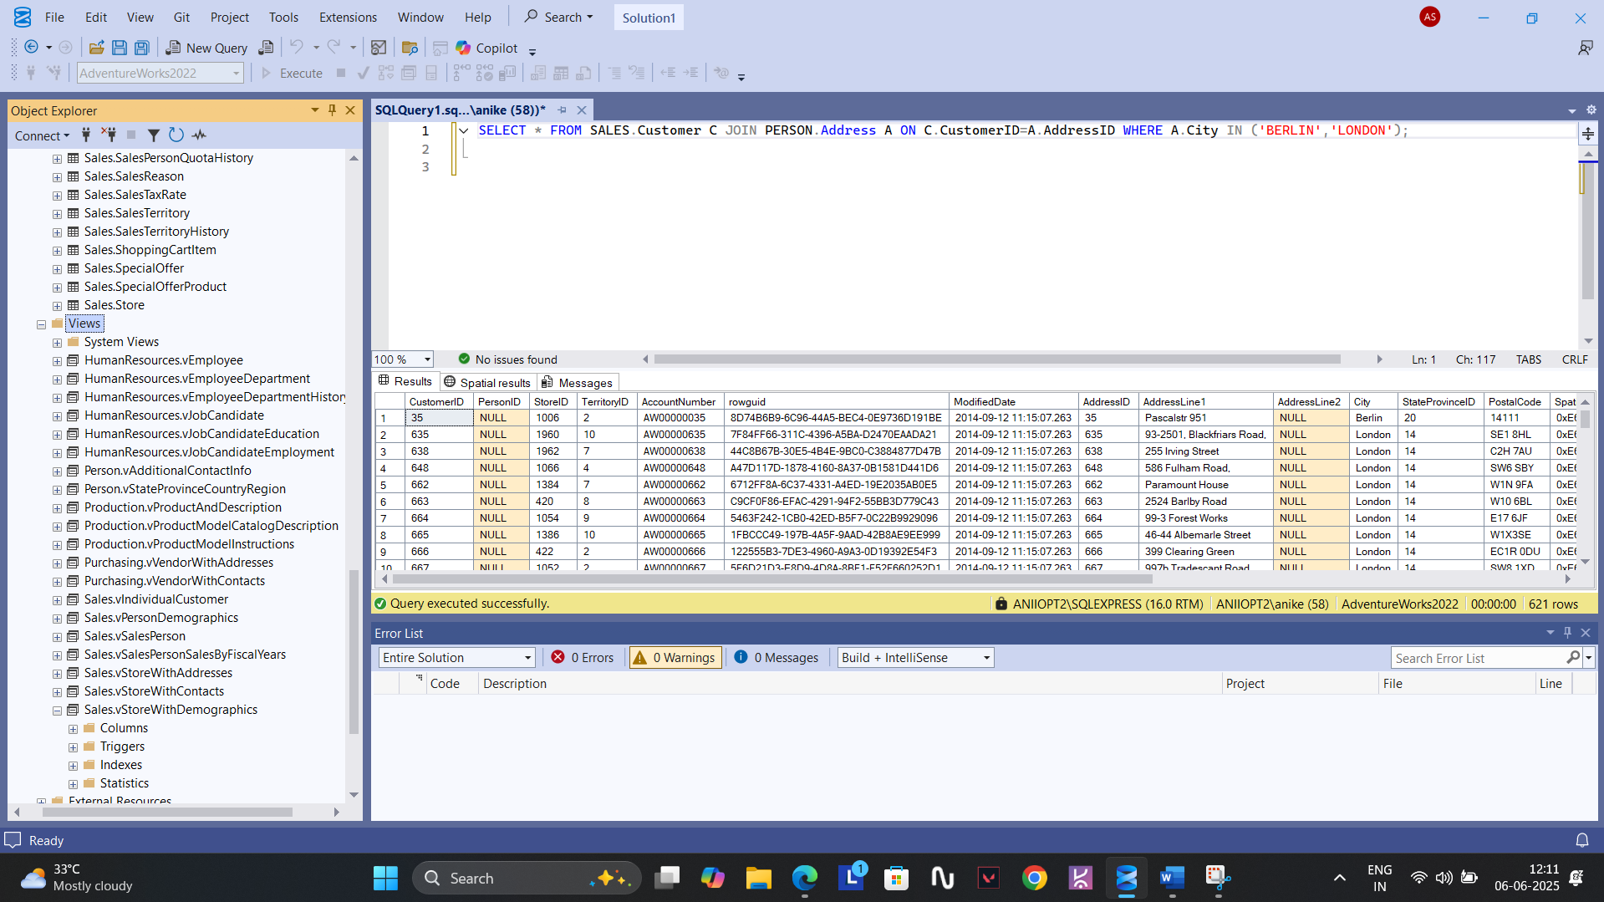

**4. SELECT C.* FROM SALES.Customer C JOIN PERSON.Address A ON C.CustomerID=A.AddressID JOIN PERSON.StateProvince P ON**

**A.StateProvinceID=P.StateProvinceID JOIN PERSON.CountryRegion R ON P.CountryRegionCode=R.CountryRegionCode WHERE R.CountryRegionCode IN**

**('US','UK');**

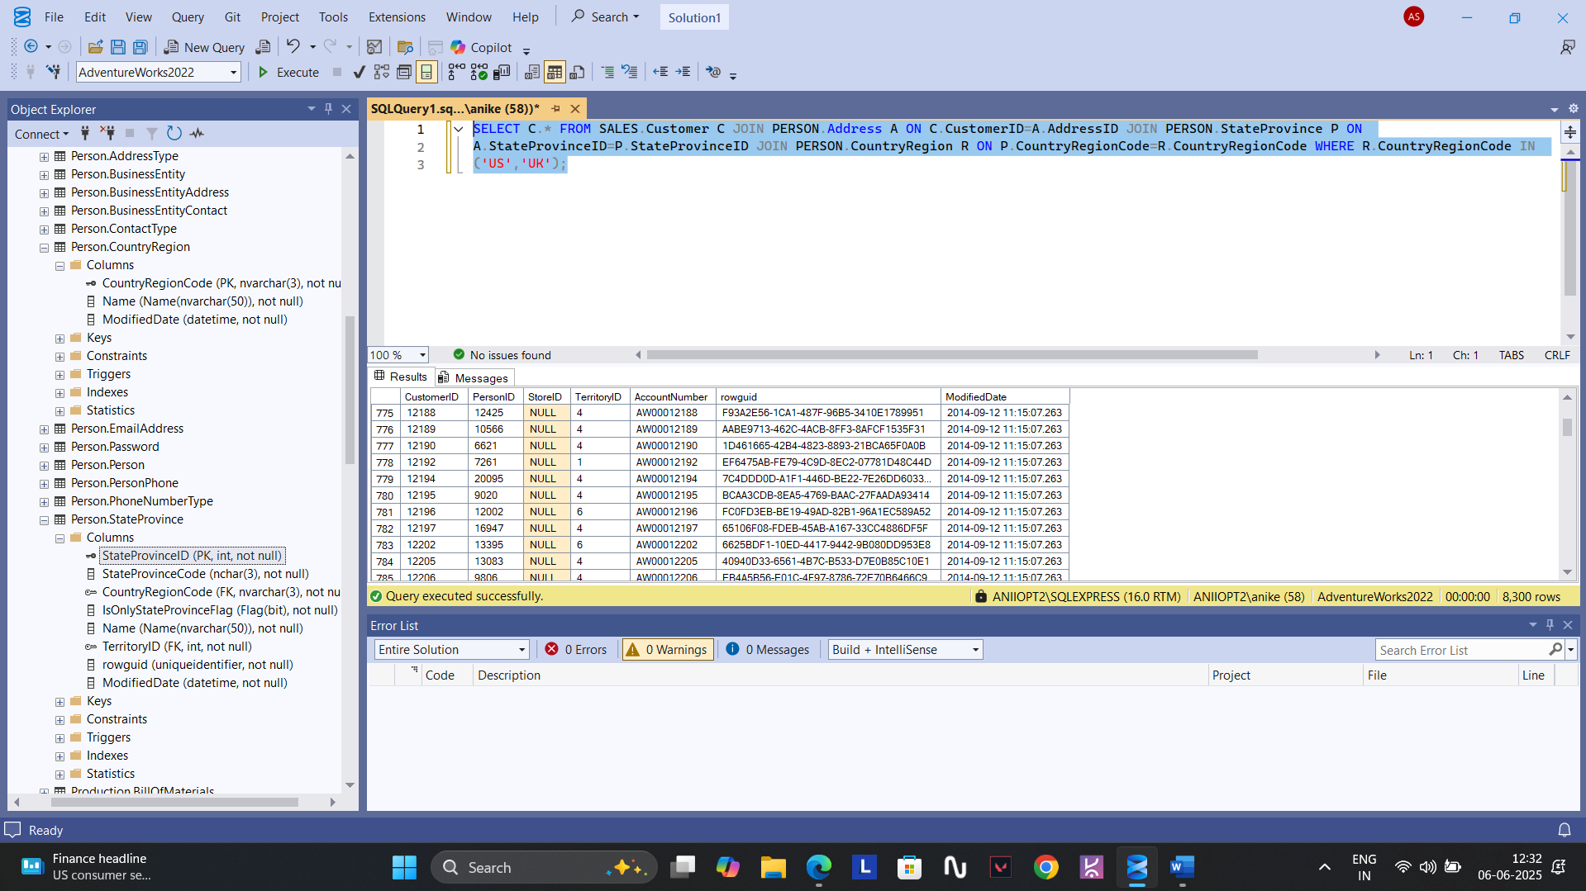

**5.** **SELECT * FROM PRODUCTION.Product ORDER BY NAME;**

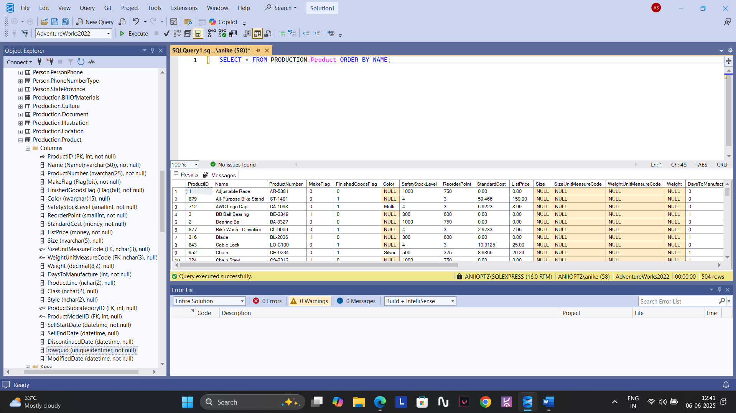

**6.** **SELECT * FROM PRODUCTION.Product WHERE NAME LIKE 'A%';**

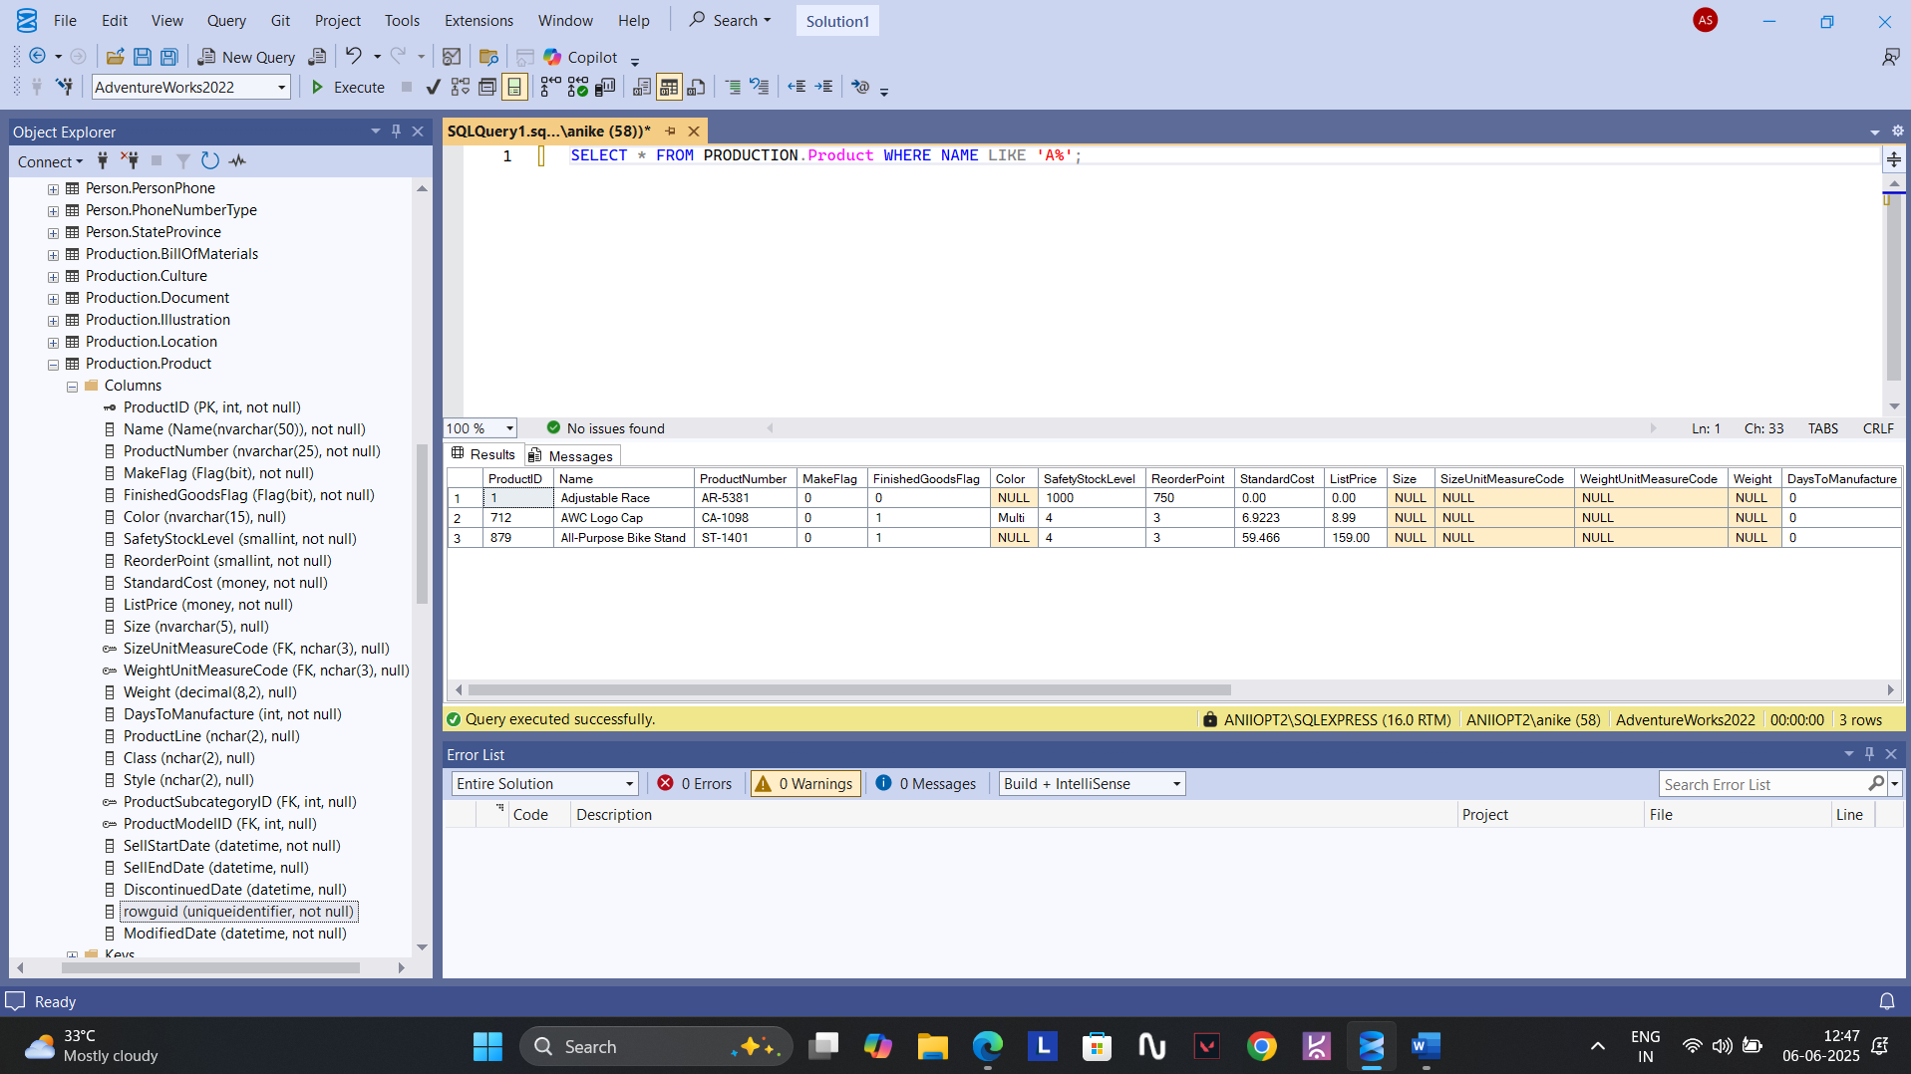

**7. SELECT C.CustomerID,P.FirstName,P.MiddleName,P.LastName FROM SALES.Customer C JOIN SALES.SalesOrderHeader SH ON C.CustomerID=SH.CustomerID JOIN PERSON.Person P ON C.PersonID=P.BusinessEntityID;**

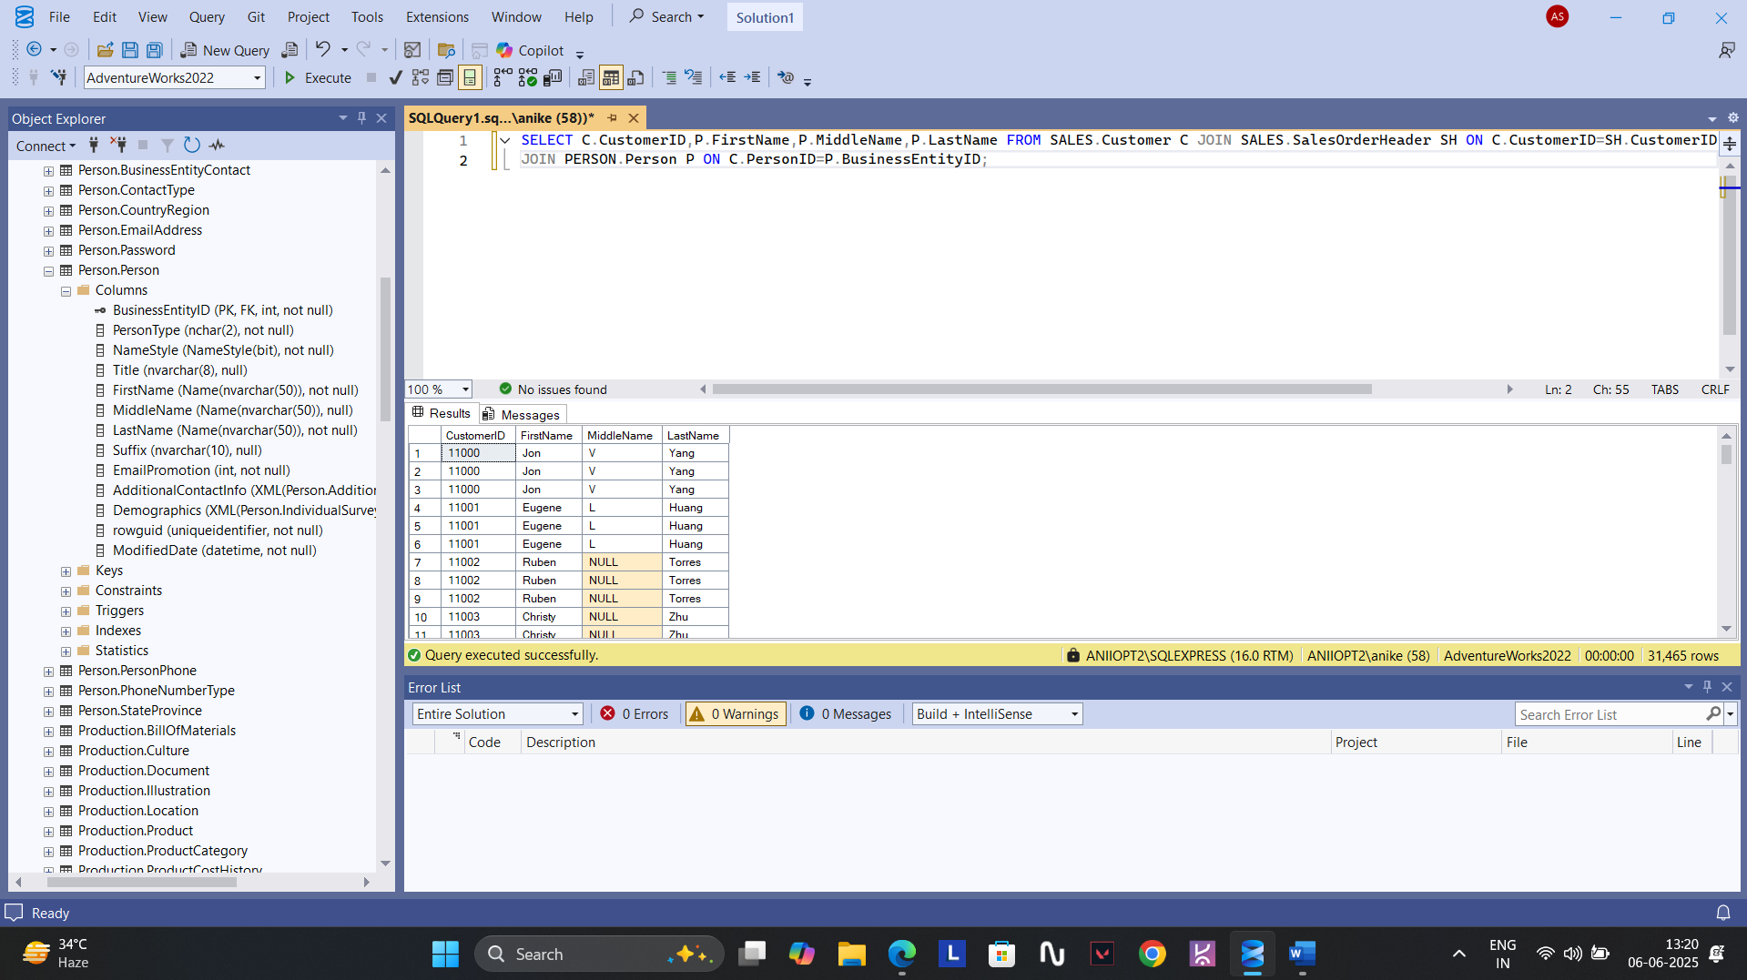

**8. In this database a product name “Chai” doesn’t exists.**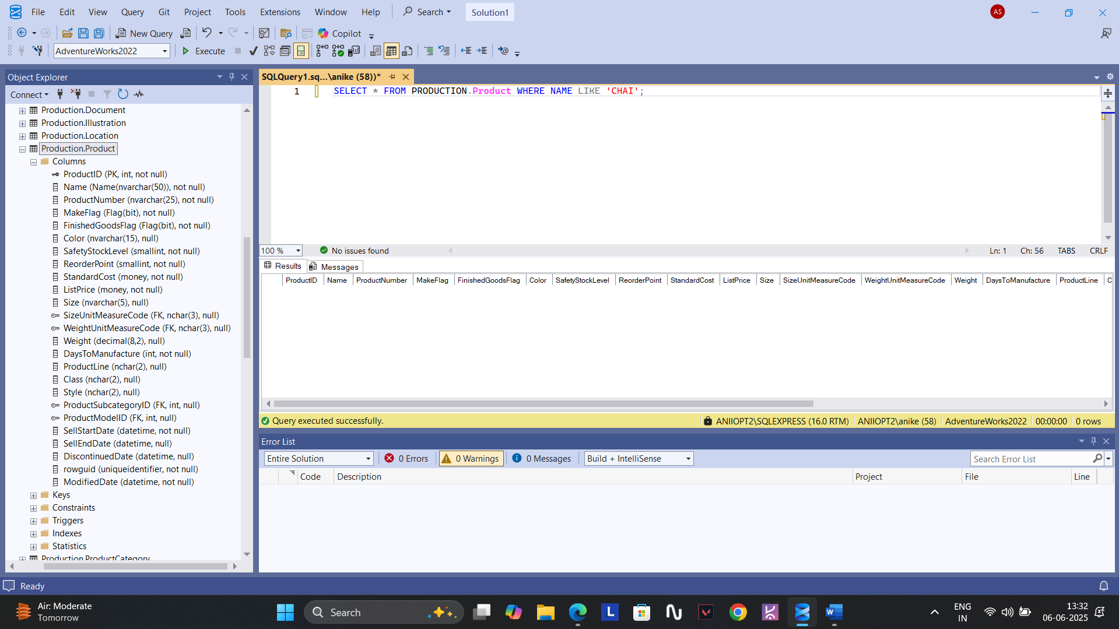

**9.** **SELECT C.CustomerID,P.FirstName,P.MiddleName,P.LastName FROM SALES.Customer C JOIN PERSON.Person P ON C.PersonID=P.BusinessEntityID**

**JOIN SALES.SalesOrderHeader SH ON C.CustomerID = SH.CustomerID WHERE SH.CustomerID LIKE 'NULL';**

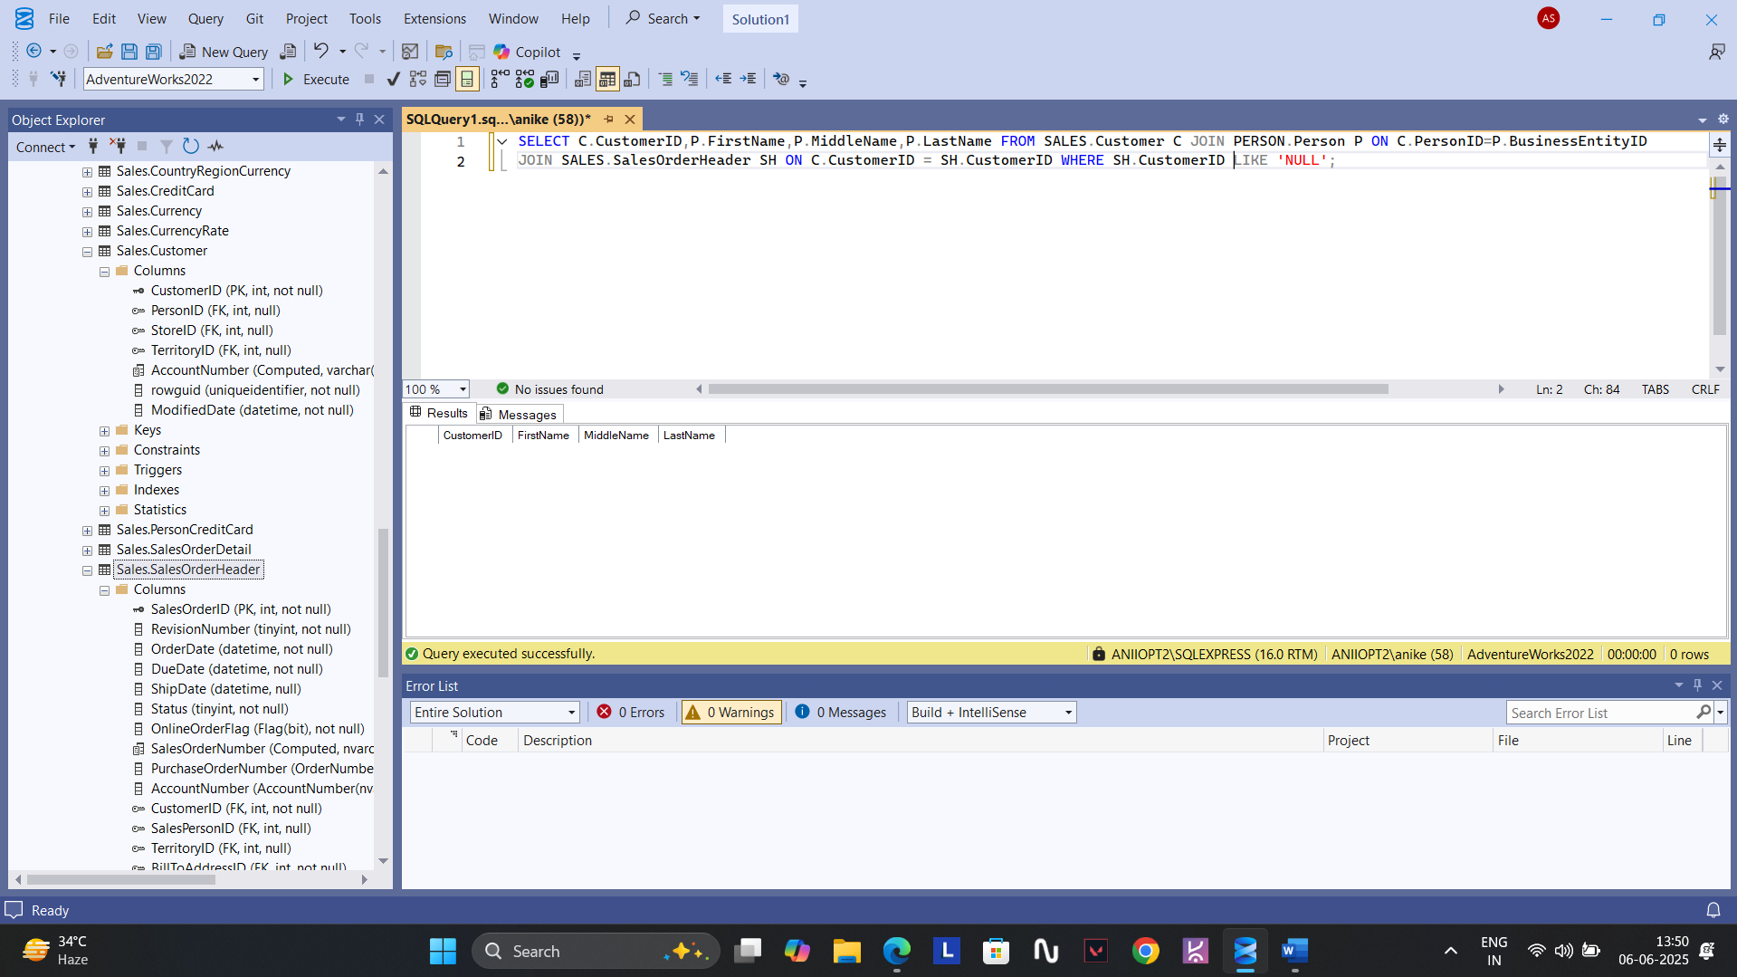

**10. No item named ‘Tofu’ exists.**

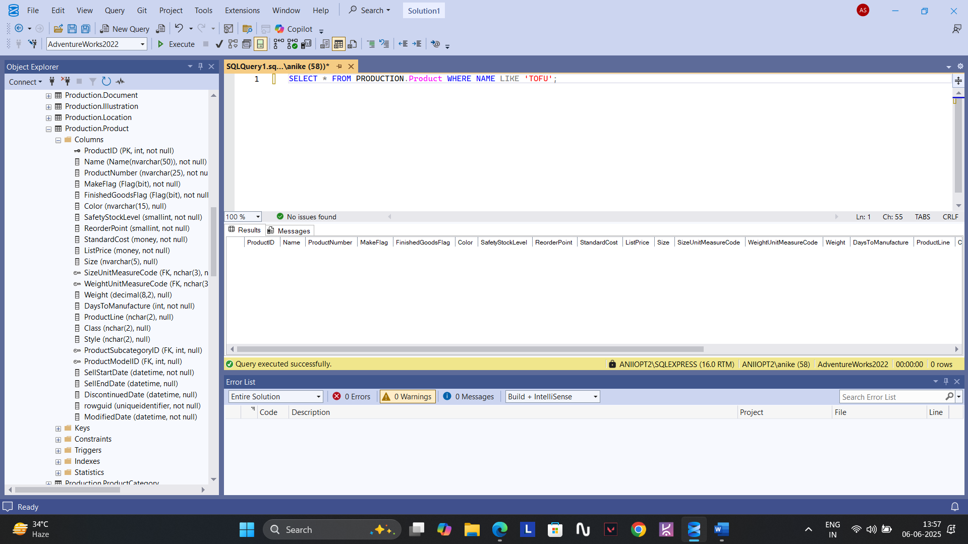

**11.** **SELECT TOP 1* FROM SALES.SalesOrderHeader ORDER BY OrderDate ASC;**

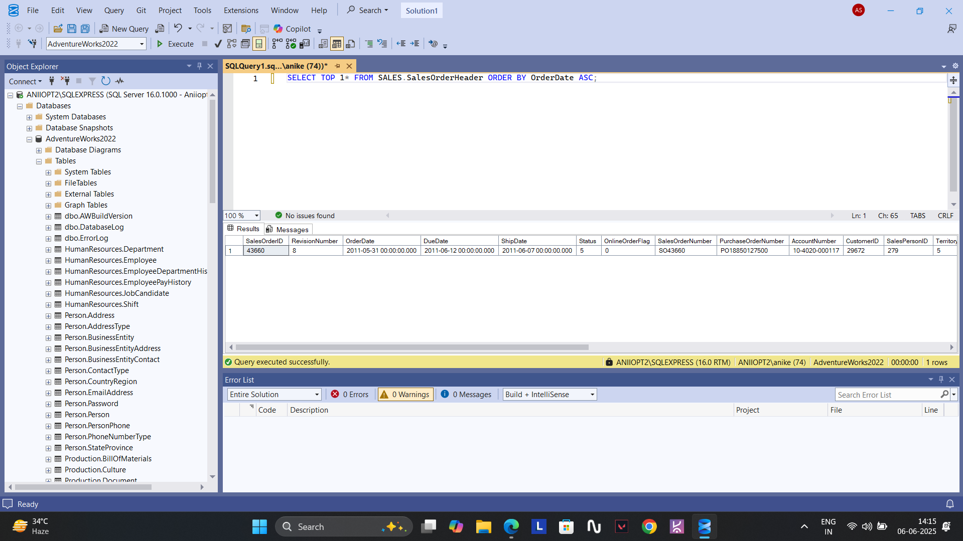

**In this question I couldn’t solve it using LIMIT .**

**12.** **SELECT TOP 1 OrderDate,TotalDue FROM SALES.SalesOrderHeader ORDER BY TotalDue DESC;**

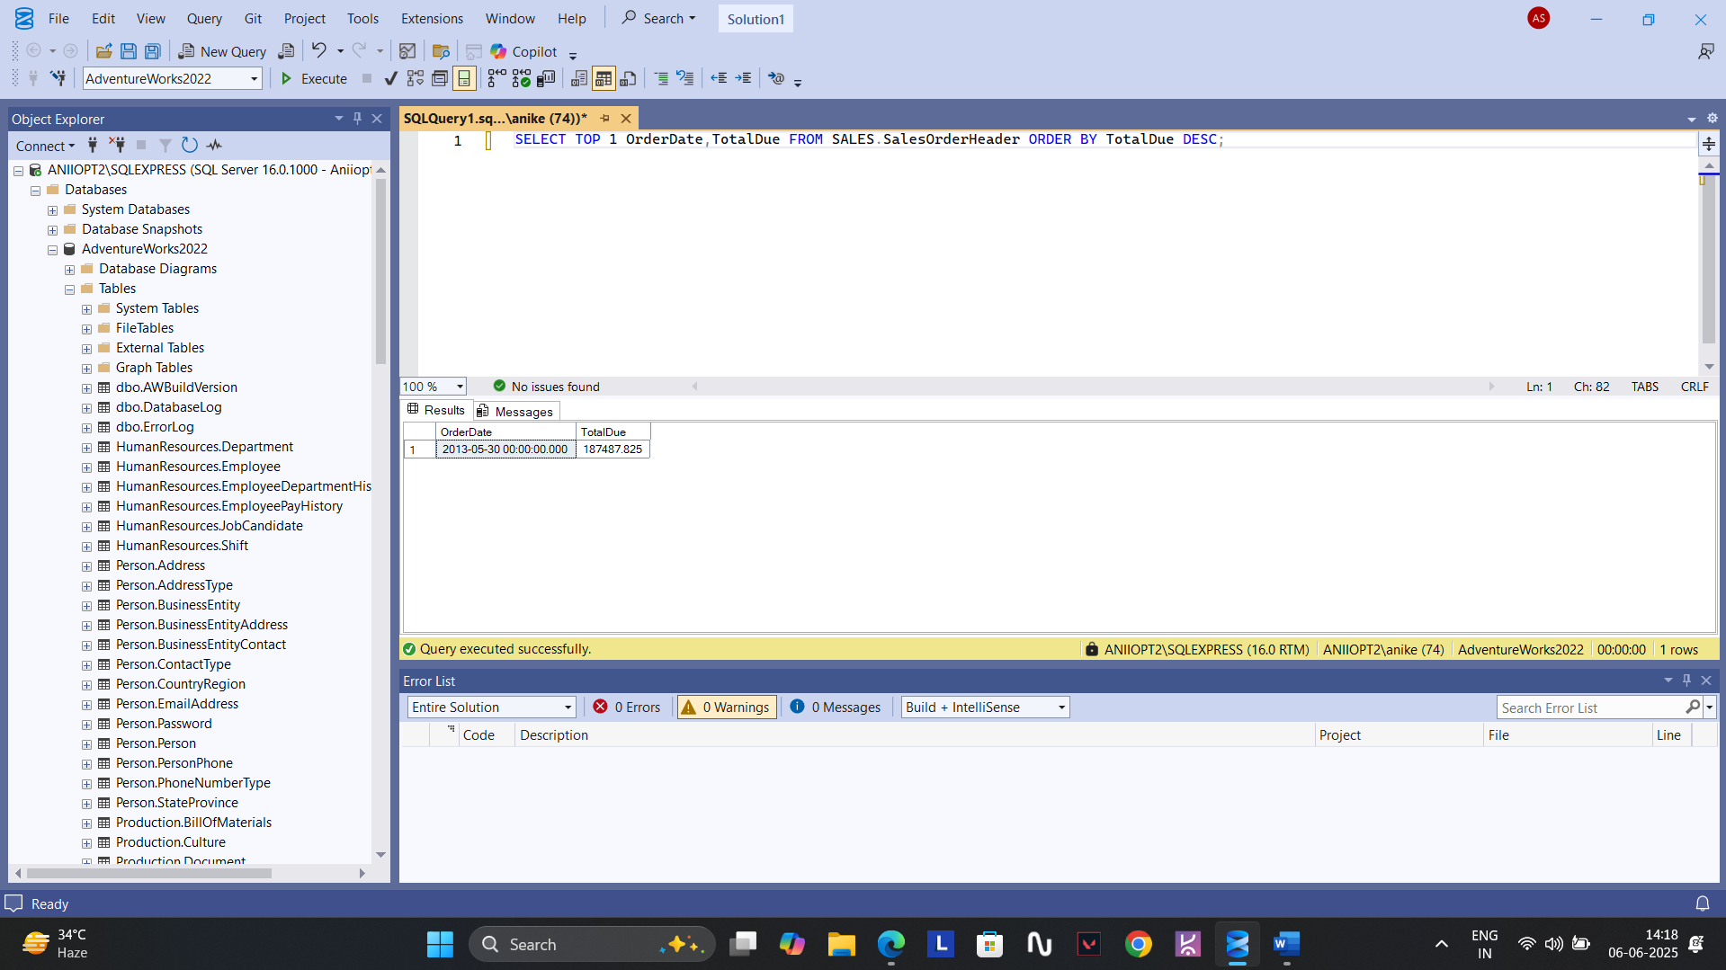

**13. SELECT SalesOrderID, AVG(OrderQty) AS AVG_ORDER_QT FROM SALES.SalesOrderDetail GROUP BY SalesOrderID;**

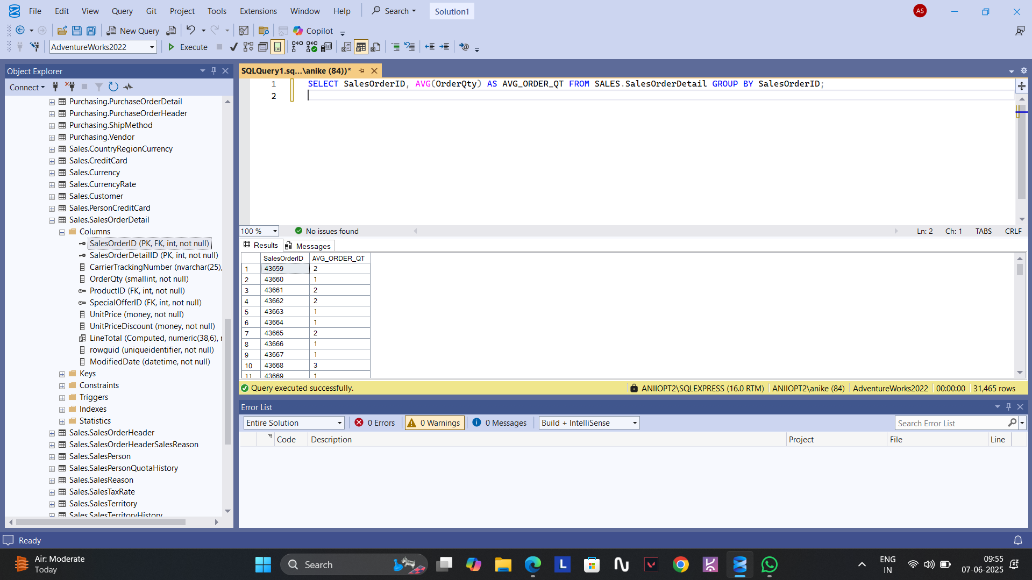

**14.** **SELECT SalesOrderID, MIN(OrderQty) AS MIN_ORDER_QT,MAX(OrderQty) AS MAX_ORDER_QT FROM SALES.SalesOrderDetail GROUP BY SalesOrderID;**

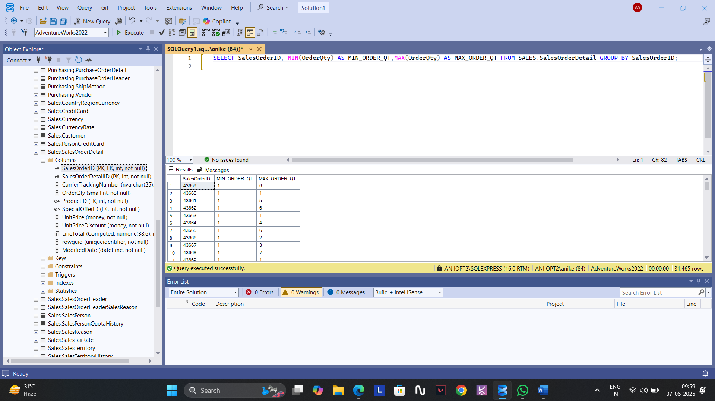

**15. SELECT E.BusinessEntityID,E.JobTitle,P.FirstName+' '+P.LastName AS MANAGER_NAME,COUNT(E.BusinessEntityID) AS WORKERCOUNT FROM**

**HUMANRESOURCES.Employee E JOIN PERSON.Person P ON P.BusinessEntityID=E.BusinessEntityID WHERE E.JobTitle LIKE '%Manager'**

**GROUP BY E.BusinessEntityID,E.JobTitle,P.FirstName,P.LastName;**

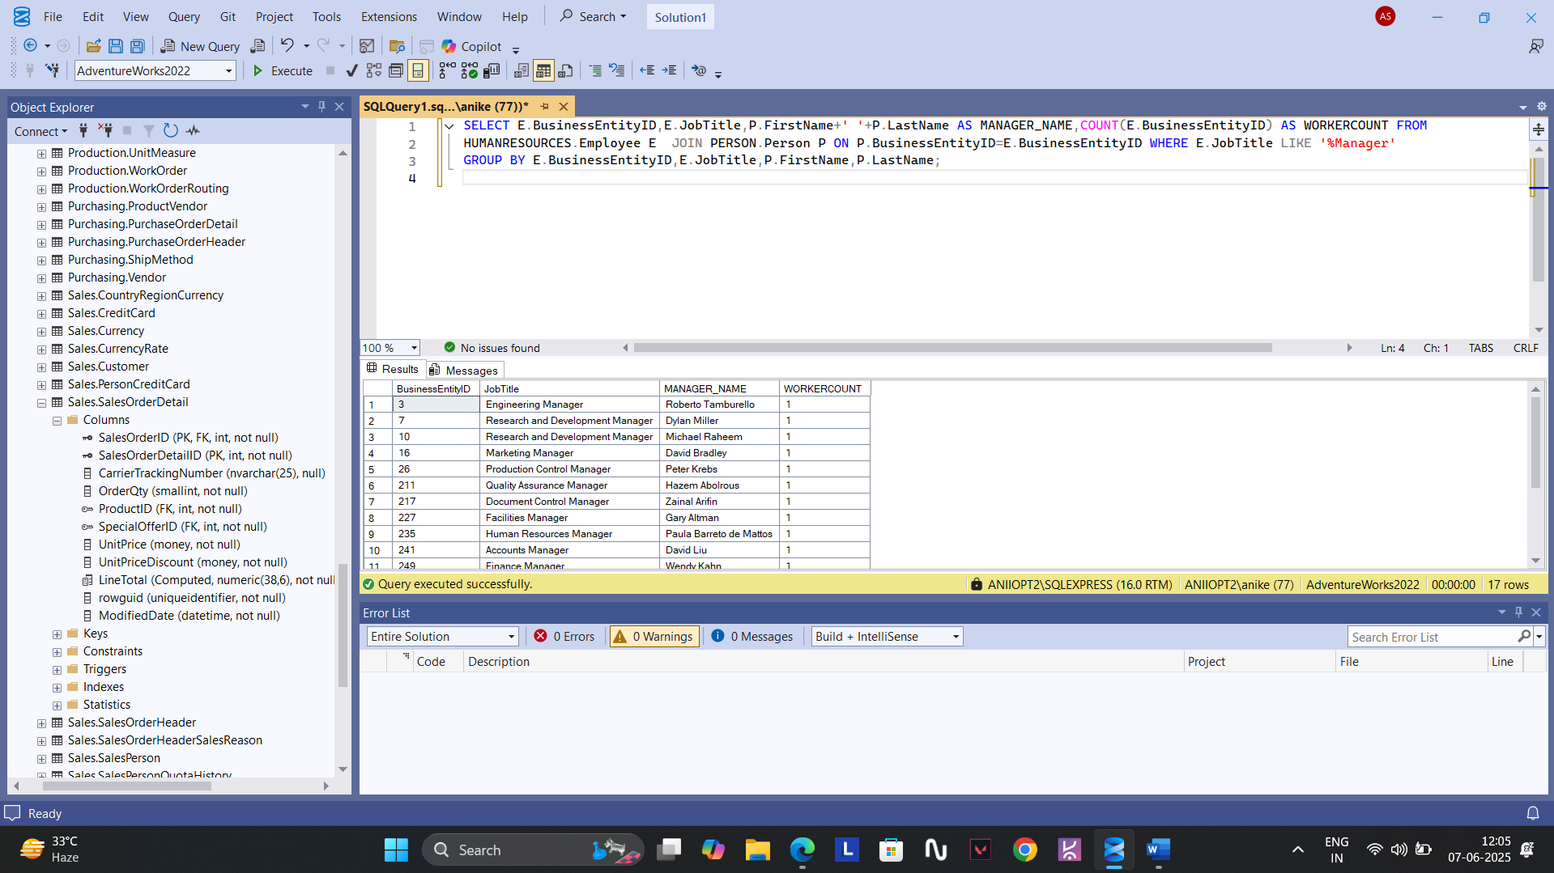

**There was some issue with the database as there were no clear information related to the workers with their respective departments.**

**16. SELECT SalesOrderID, SUM(OrderQty) AS TOTAL_ORDER_QT FROM SALES.SalesOrderDetail GROUP BY SalesOrderID HAVING SUM(OrderQty)>300;**

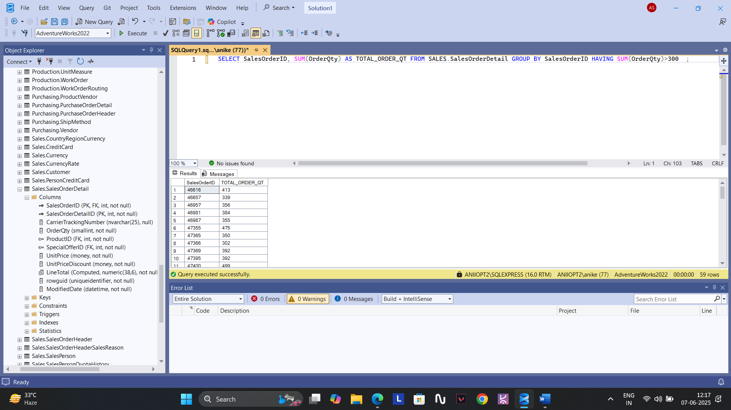

**17. SELECT * FROM SALES.SalesOrderHeader WHERE OrderDate >='1996-12-31';**

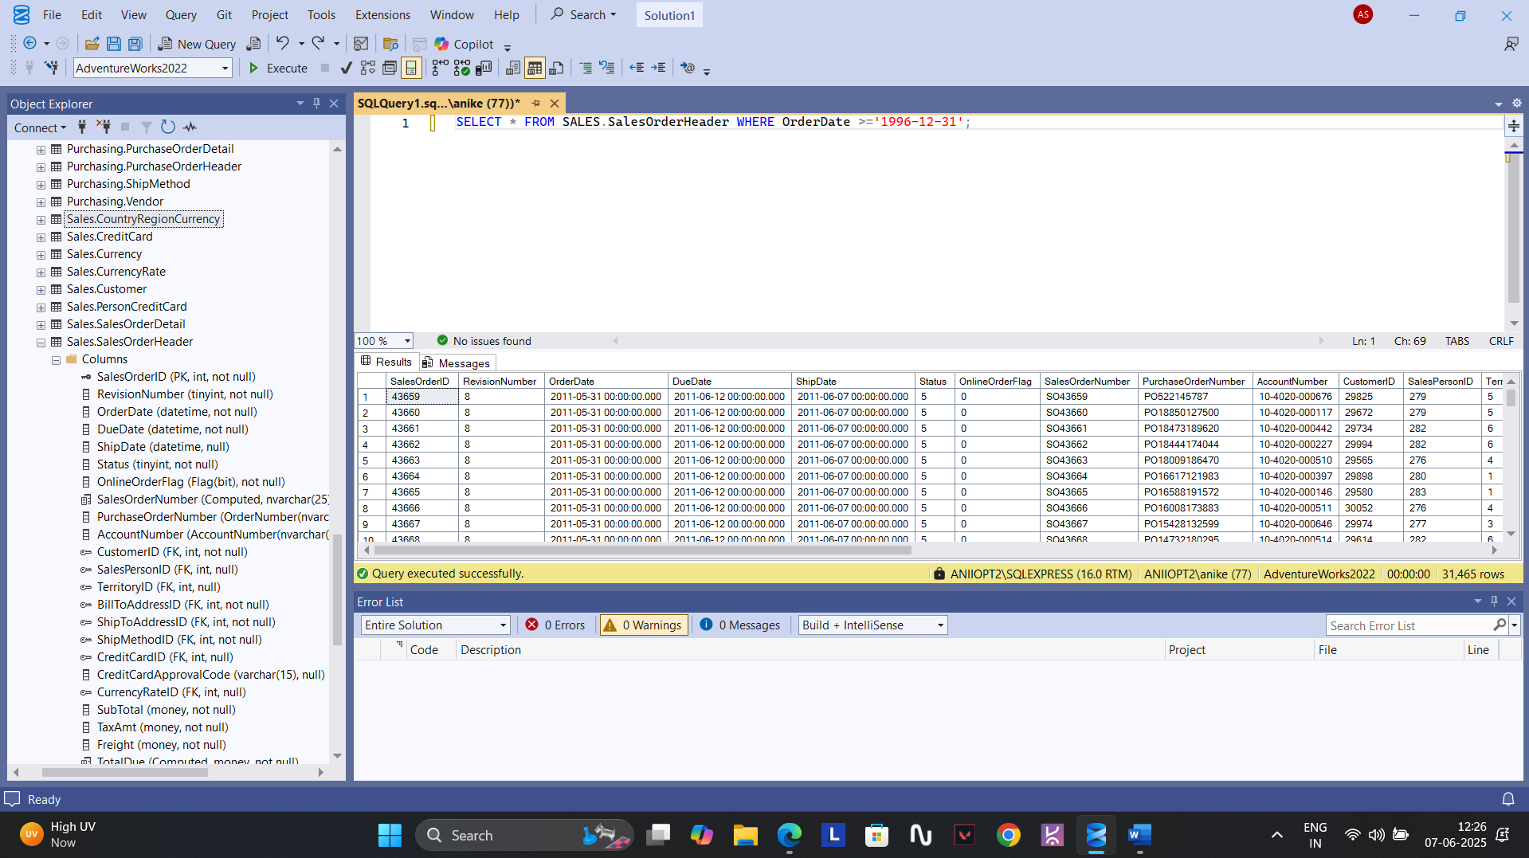

**18.** **SELECT SH.* FROM SALES.SalesOrderHeader SH JOIN PERSON.Address A ON SH.ShipToAddressID=A.AddressID**

**JOIN PERSON.StateProvince SP ON A.StateProvinceID=SP.StateProvinceID JOIN PERSON.CountryRegion C ON**

**SP.CountryRegionCode=C.CountryRegionCode WHERE C.CountryRegionCode = 'CA';**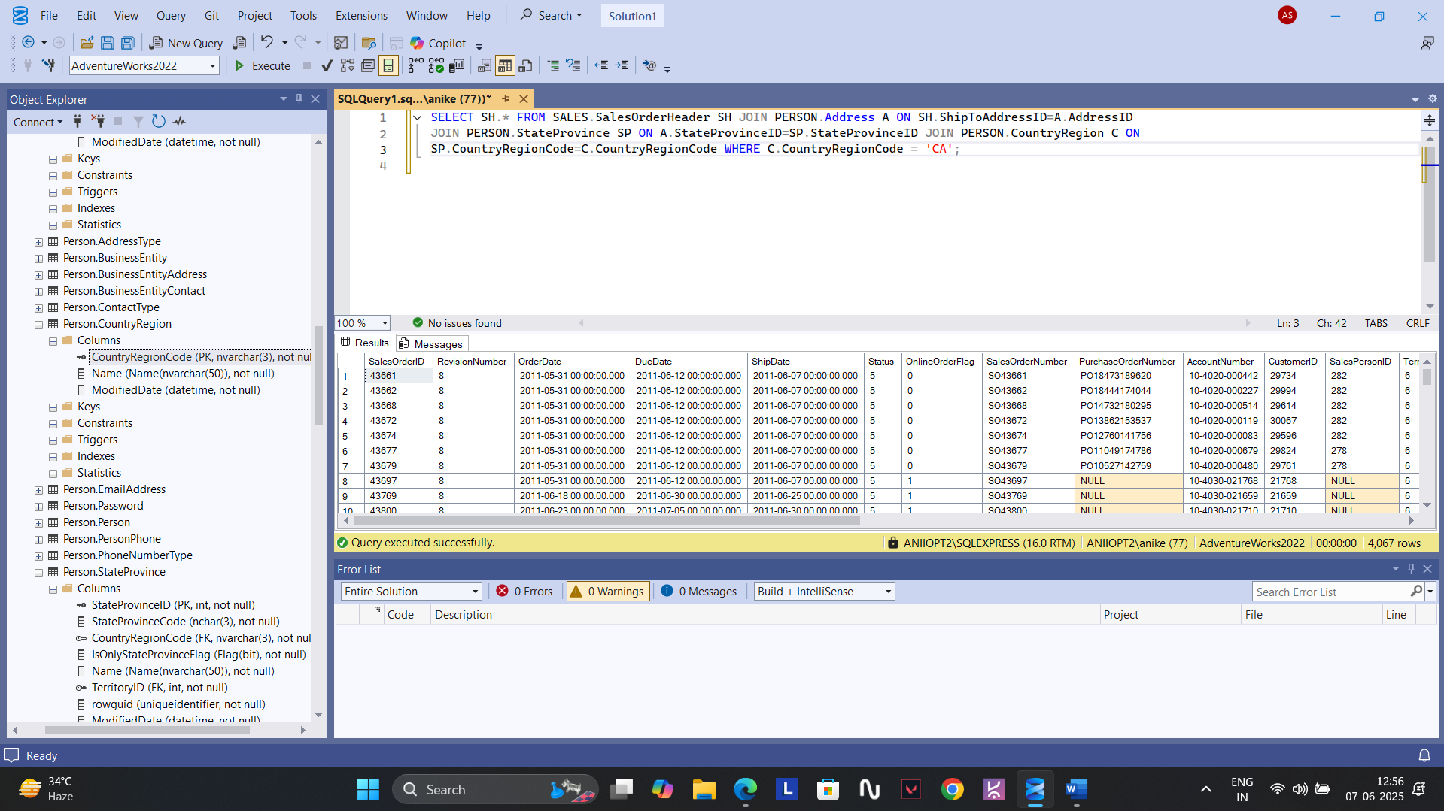

**19. SELECT * FROM SALES.SalesOrderHeader WHERE TotalDue>200;**

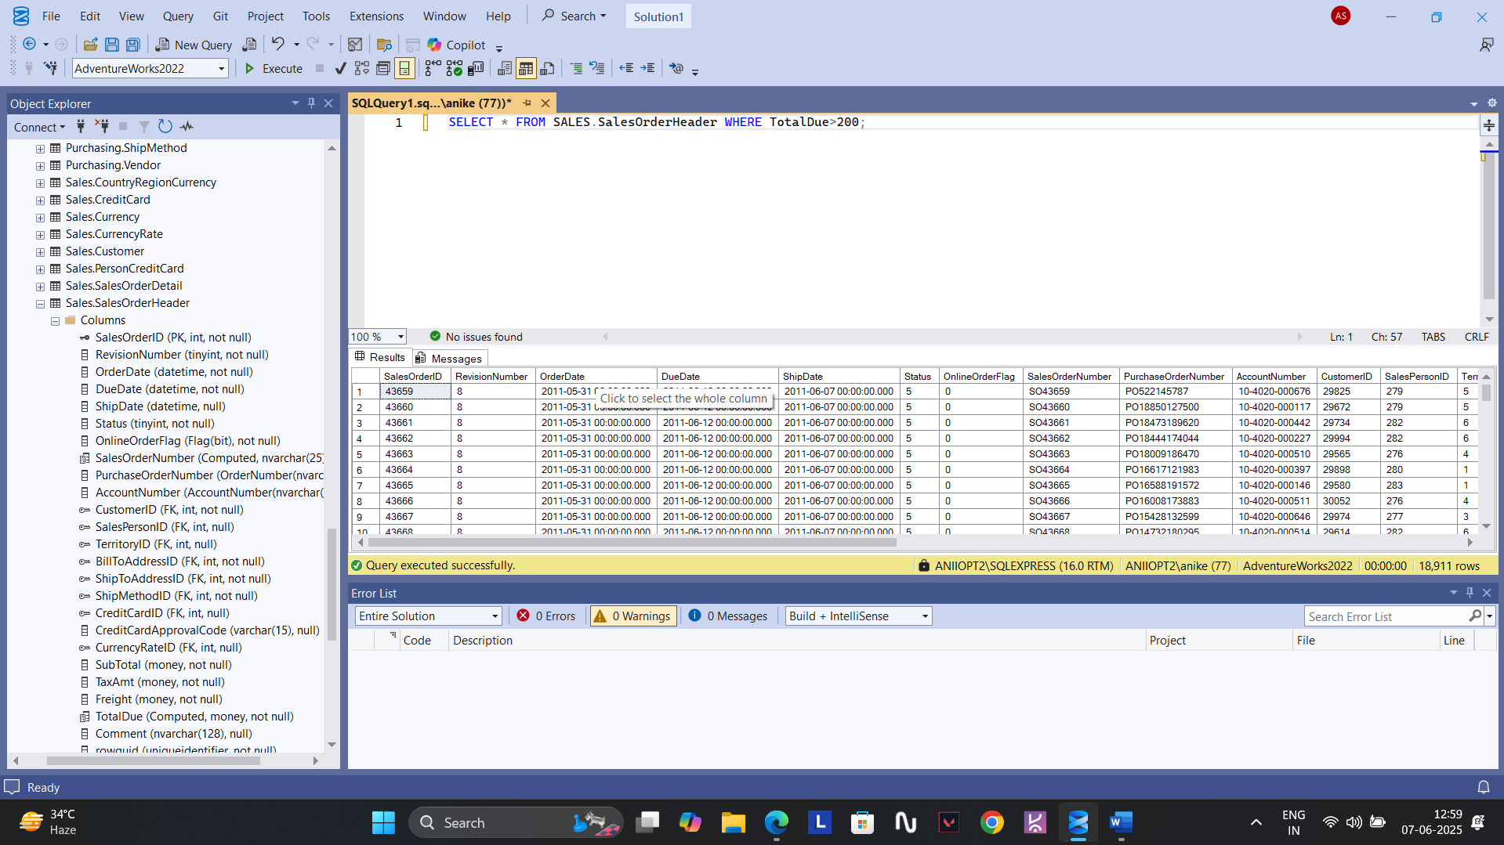

**20.** **SELECT C.NAME,SUM(TOTALDUE) AS SALES FROM SALES.SalesOrderHeader SH JOIN PERSON.Address A ON SH.ShipToAddressID=A.AddressID**

**JOIN PERSON.StateProvince SP ON A.StateProvinceID=SP.StateProvinceID JOIN PERSON.CountryRegion C ON**

**SP.CountryRegionCode=C.CountryRegionCode GROUP BY C.Name;**

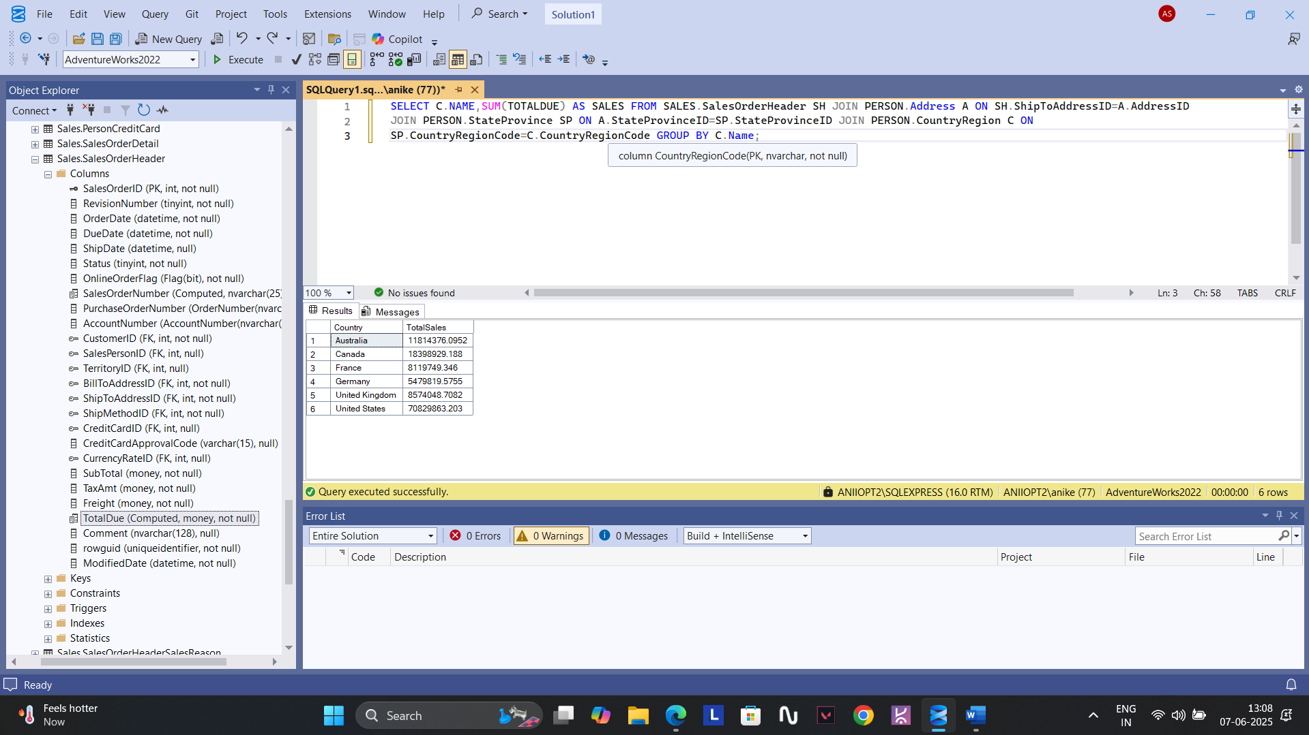

**21. SELECT P.FIRSTNAME,P.LASTNAME,COUNT(SalesOrderID) AS ORDER_COUNT FROM SALES.SalesOrderHeader SH**

**JOIN PERSON.Person P ON SH.CustomerID=P.BusinessEntityID GROUP BY P.FirstName,P.LastName;**

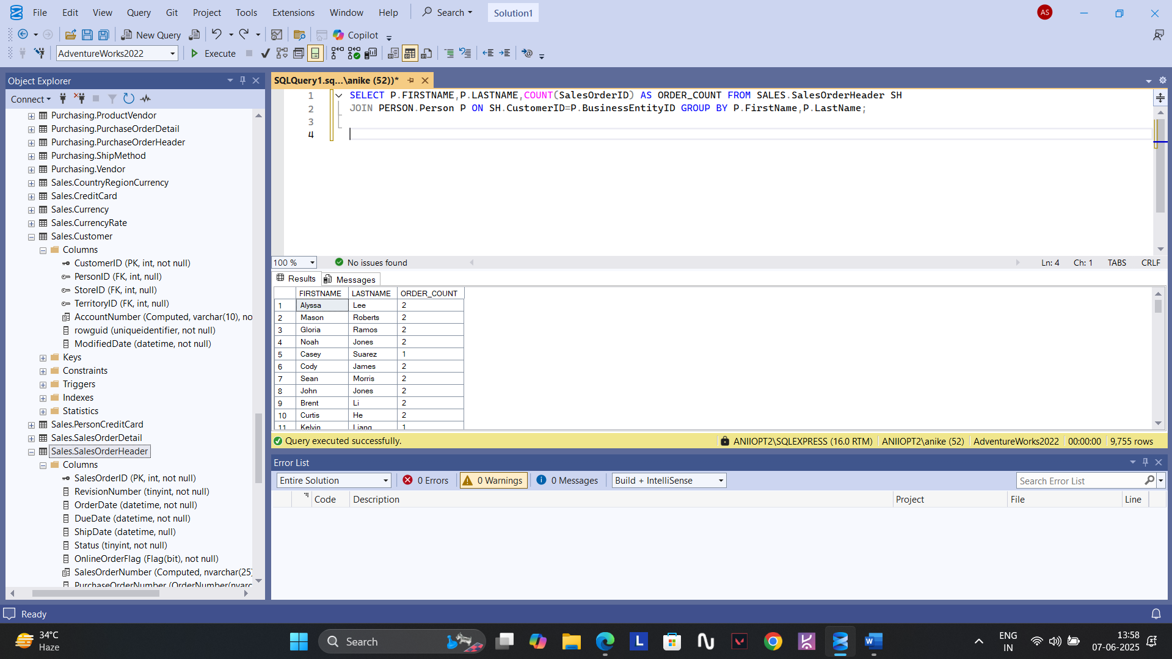

**22.** **SELECT P.FIRSTNAME,P.LASTNAME,COUNT(SalesOrderID) AS ORDER_COUNT FROM SALES.SalesOrderHeader SH**

**JOIN PERSON.Person P ON SH.CustomerID=P.BusinessEntityID GROUP BY P.FirstName,P.LastName HAVING COUNT(SalesOrderID)>3;**

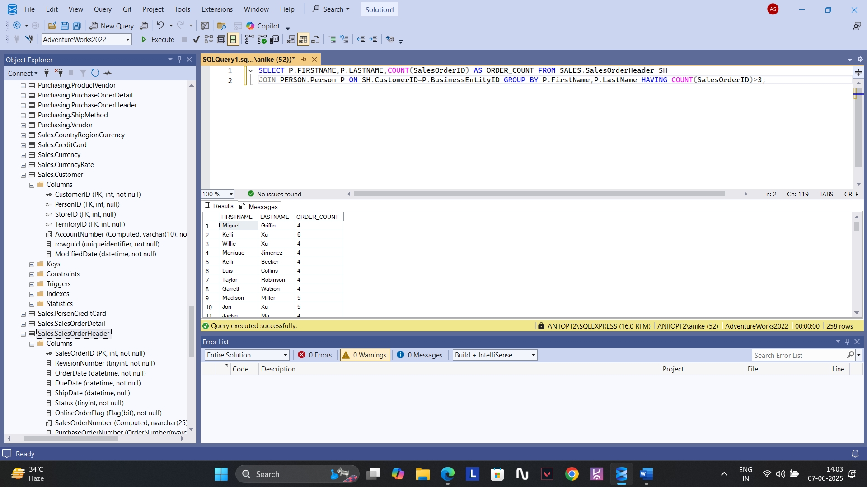

**23. No product shipped during the given dates.**

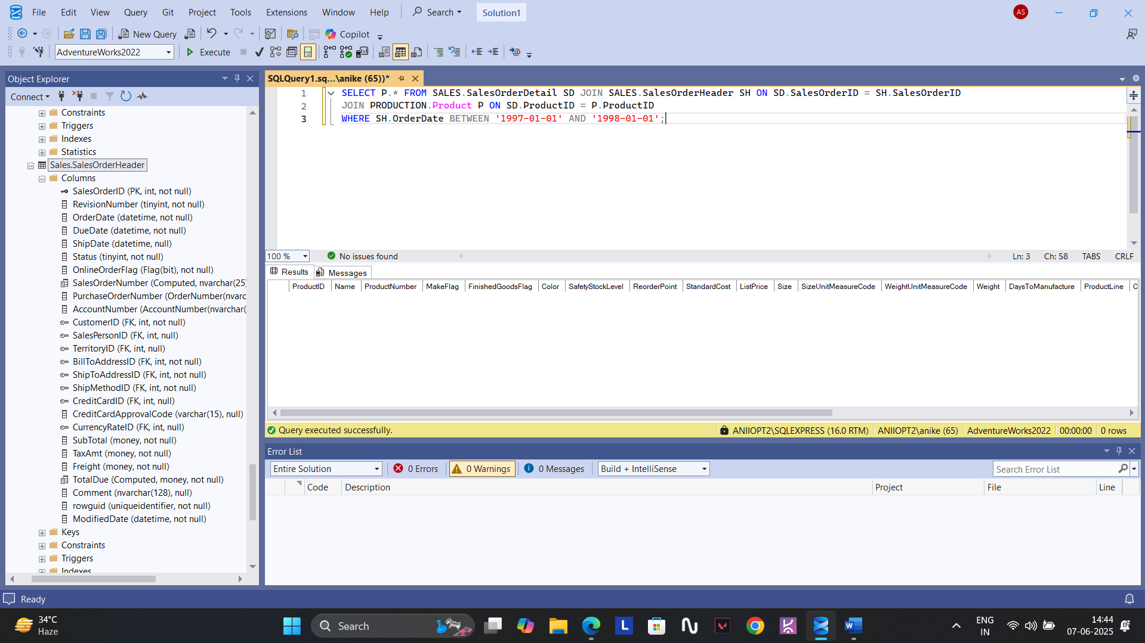

**24.**

**Don’t know the answer.**

**25. SELECT SalesPersonID, SUM(TotalDue) AS TOTAL_SALES FROM SALES.SalesOrderHeader WHERE SalesPersonID IS NOT NULL GROUP BY SalesPersonID;**

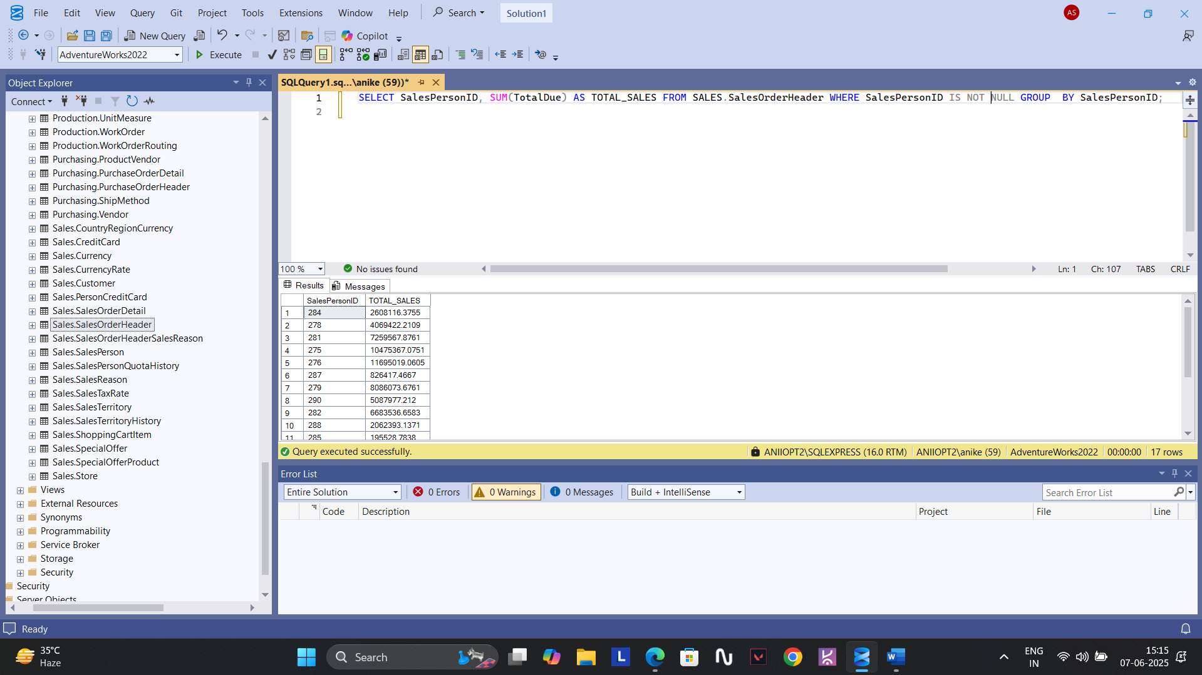

**26. SELECT * FROM PERSON.Person WHERE FirstName LIKE '%A%';**

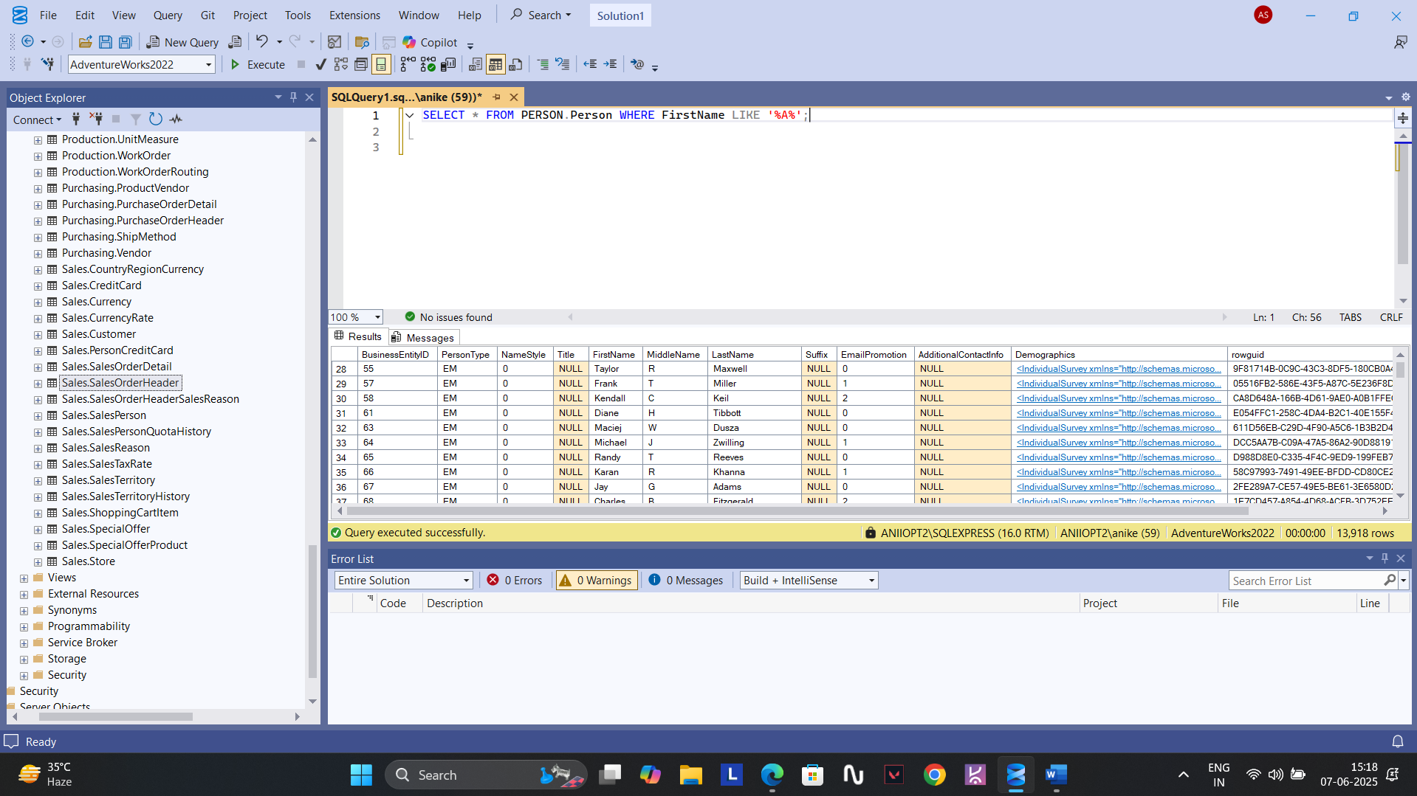

**27.**

**DON’T KNOW.**

**28.** **SELECT SD.SALESORDERID,P.NAME AS PRODUCT_NAME FROM PRODUCTION.PRODUCT P JOIN SALES.SALESORDERDETAIL SD ON**

**P.PRODUCTID=SD.PRODUCTID JOIN SALES.SALESORDERHEADER SH ON SD.SALESORDERID=SH.SALESORDERID;**

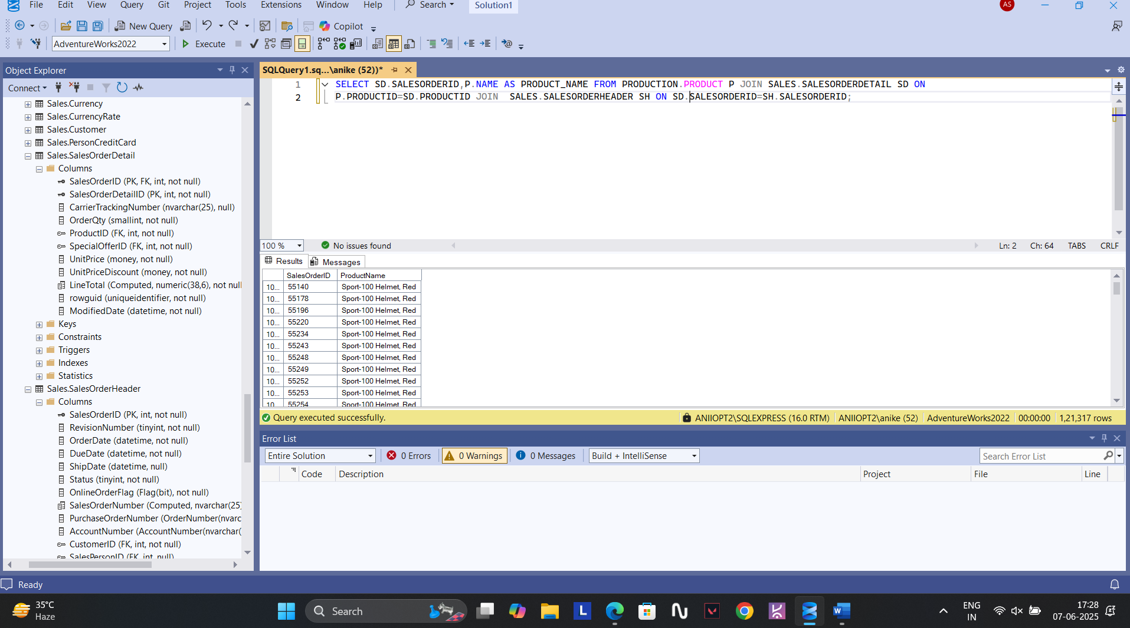

**29.** **SELECT TOP 1 C.CUSTOMERID,COUNT(*) AS ORDER_COUNT FROM SALES.SalesOrderHeader SH JOIN SALES.Customer C ON SH.CustomerID=C.CustomerID**

**GROUP BY C.CustomerID ORDER BY ORDER_COUNT DESC;**

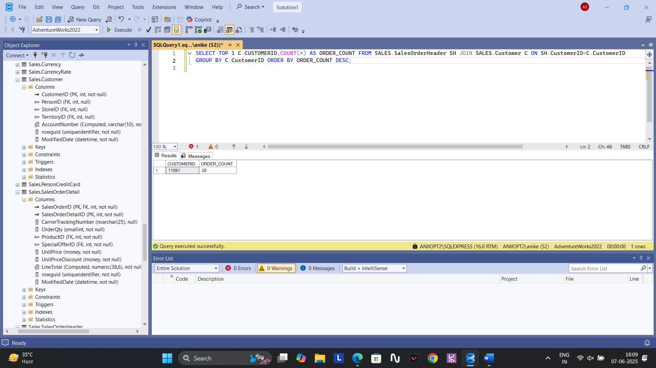

**30. There is no attribute as Fax Number.**

**31. No Product named Tofu.**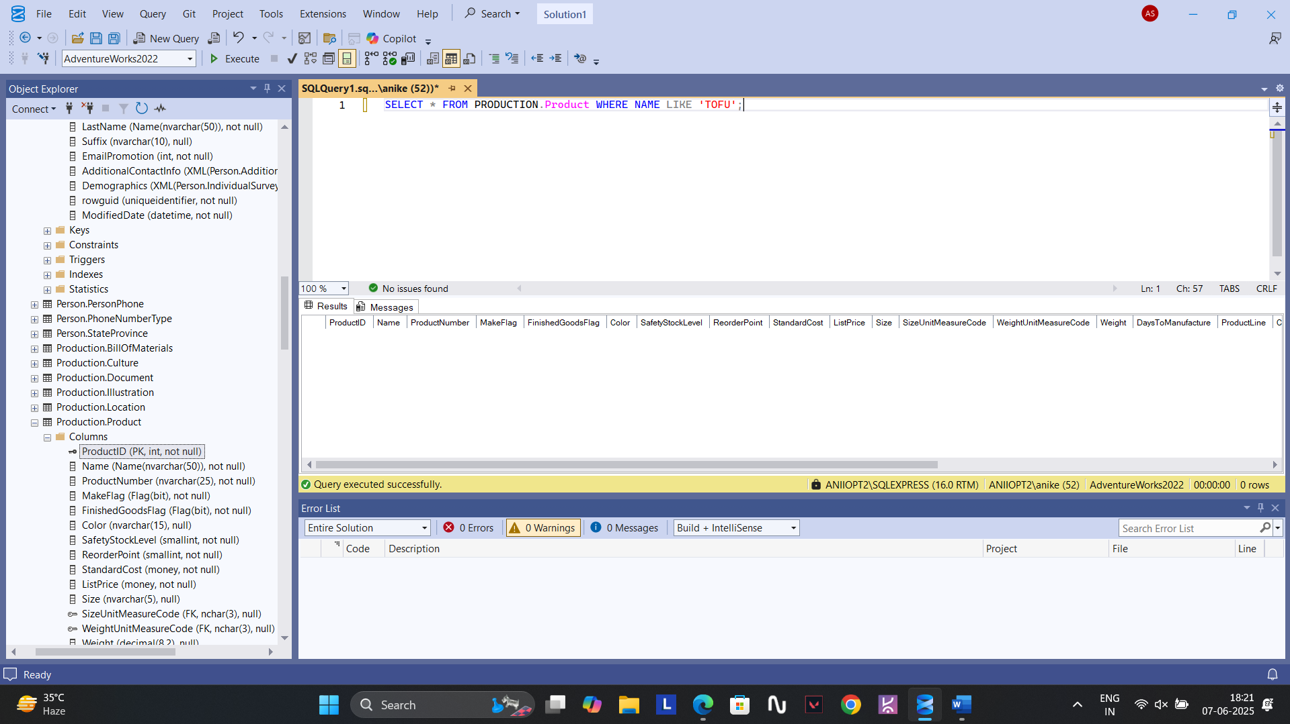

**32.** **SELECT P.ProductID,P.Name FROM PRODUCTION.Product P JOIN SALES.SalesOrderDetail SD ON P.ProductID=SD.ProductID JOIN SALES.SalesOrderHeader**

**SH ON SD.SalesOrderID=SH.SalesOrderID JOIN PERSON.Address A ON SH.ShipToAddressID=A.AddressID JOIN PERSON.StateProvince SP ON**

**A.StateProvinceID=SP.StateProvinceID JOIN PERSON.CountryRegion C ON SP.CountryRegionCode=C.CountryRegionCode**

**WHERE C.CountryRegionCode = 'FR';**

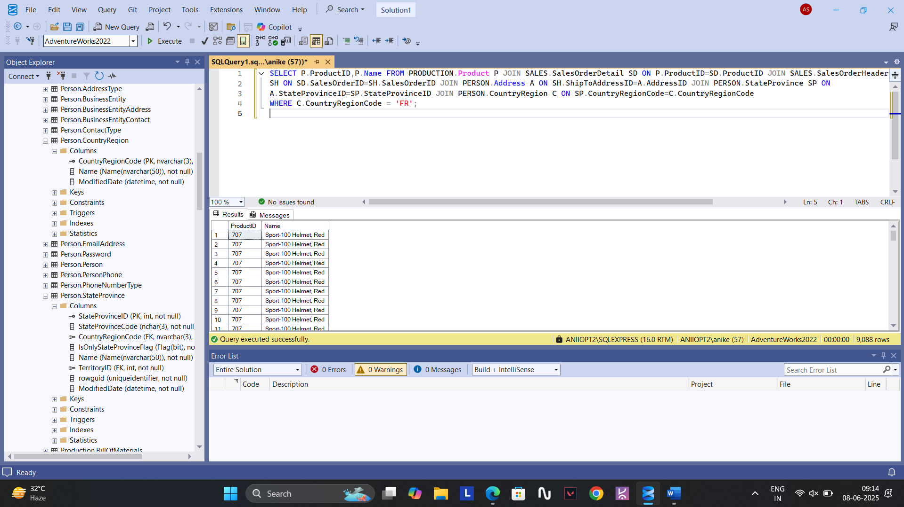

**33.No vendor named ‘Speciality biscuits, Ltd.’.**

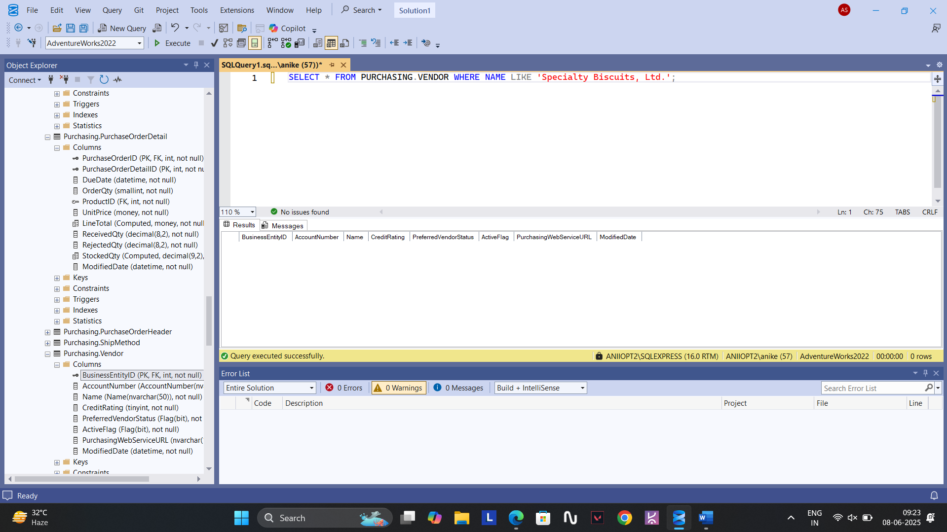

**34.** **SELECT P.Name,P.ProductNumber FROM PRODUCTION.Product P LEFT JOIN SALES.SalesOrderDetail SD ON P.ProductID=SD.ProductID WHERE SD.SalesOrderID IS NULL;**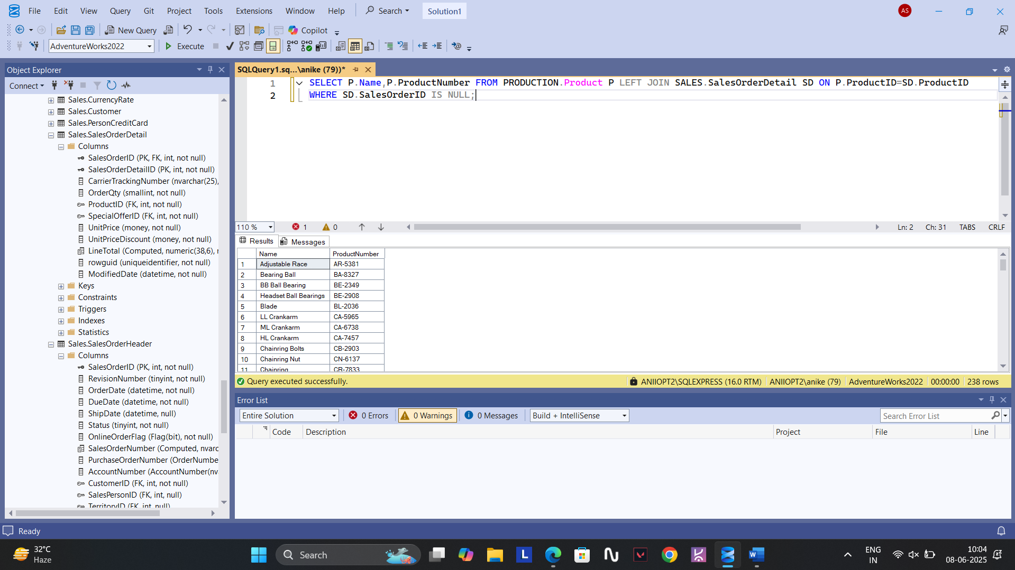

**35.** **SELECT NAME , PRODUCTNUMBER FROM PRODUCTION.Product WHERE SafetyStockLevel<10 AND ReorderPoint=0;**

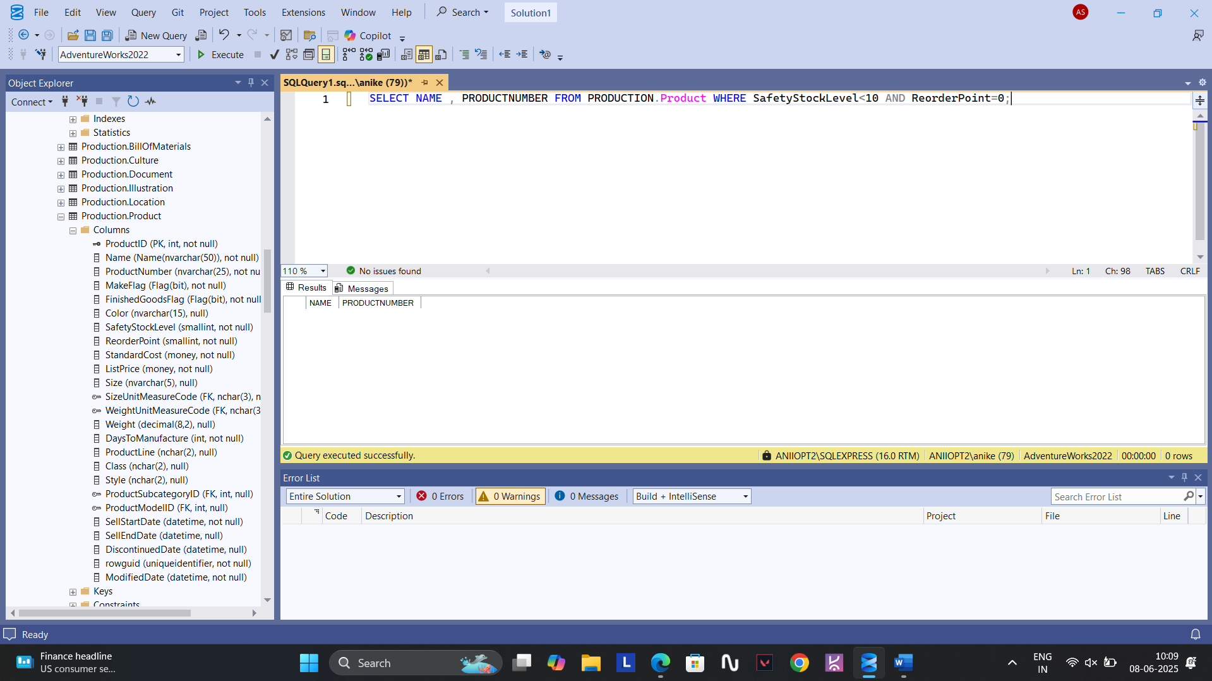

**36.** **SELECT TOP 10 C.NAME,SUM(TOTALDUE) AS TOTAL_SALES FROM SALES.SalesOrderHeader SH JOIN PERSON.StateProvince SP ON**

**SH.TerritoryID=SP.TerritoryID JOIN PERSON.CountryRegion C ON SP.CountryRegionCode=C.CountryRegionCode**

**GROUP BY C.Name ORDER BY TOTAL_SALES DESC;**

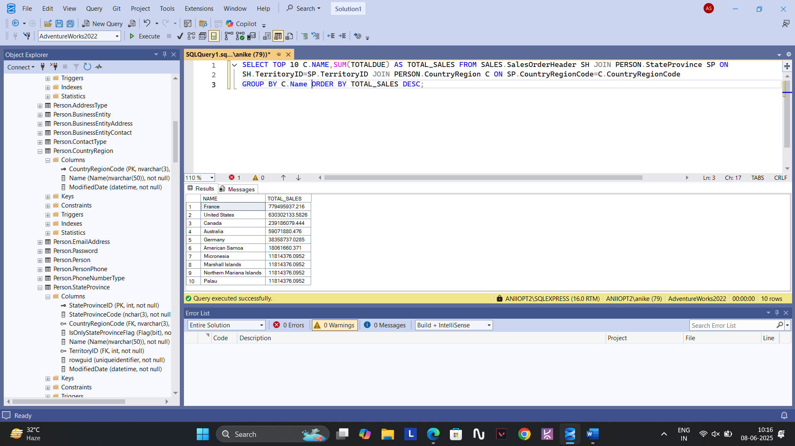

**37. As we can see the CustomerID is numeric it doesn’t contain ‘A’ or ‘AO’.**

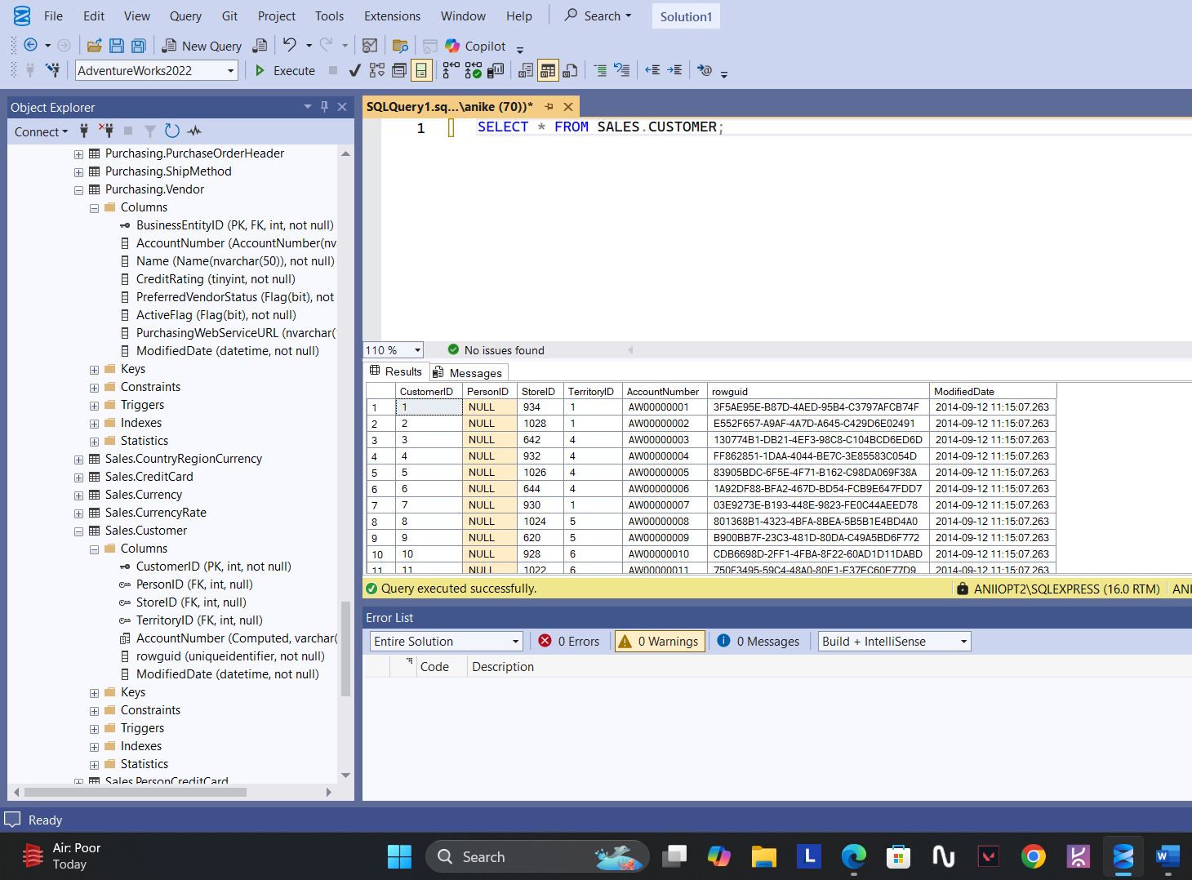

**38.** **SELECT TOP 1 OrderDate,TotalDue AS TOTAL_SALE FROM SALES.SalesOrderHeader ORDER BY TotalDue DESC;**

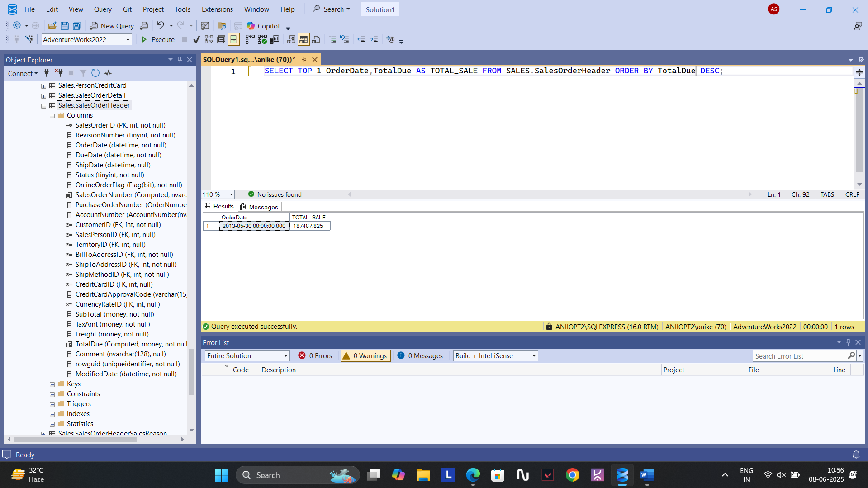

**39.** **SELECT P.NAME AS PRODUCT_NAME,SUM(SD.LineTotal) AS TOTAL_SALES FROM PRODUCTION.Product P JOIN SALES.SalesOrderDetail SD ON**

**P.ProductID=SD.ProductID JOIN SALES.SalesOrderHeader SH ON SD.SalesOrderID = SH.SalesOrderID GROUP BY P.NAME**

**ORDER BY TOTAL_SALES DESC;**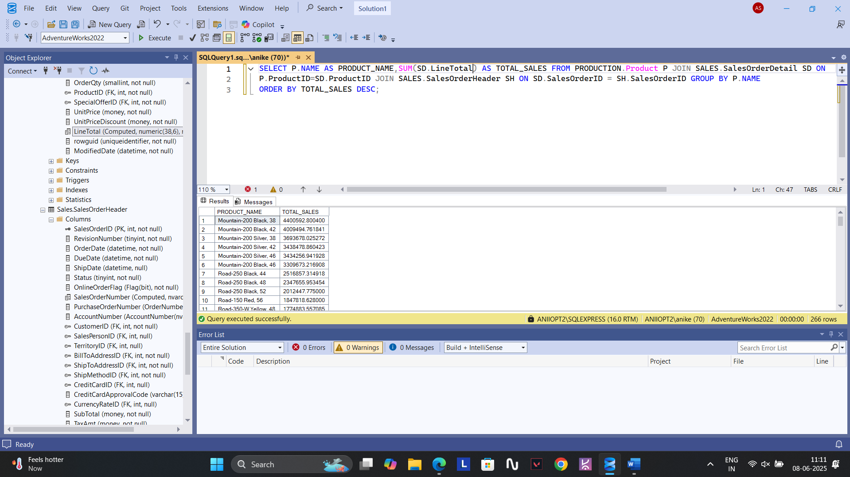

**40.** **SELECT BUSINESSENTITYID AS SUPPLIER_ID,COUNT(PRODUCTID) AS PRODUCT_COUNT FROM PURCHASING.ProductVendor**

**GROUP BY BusinessEntityID ORDER BY PRODUCT_COUNT;**

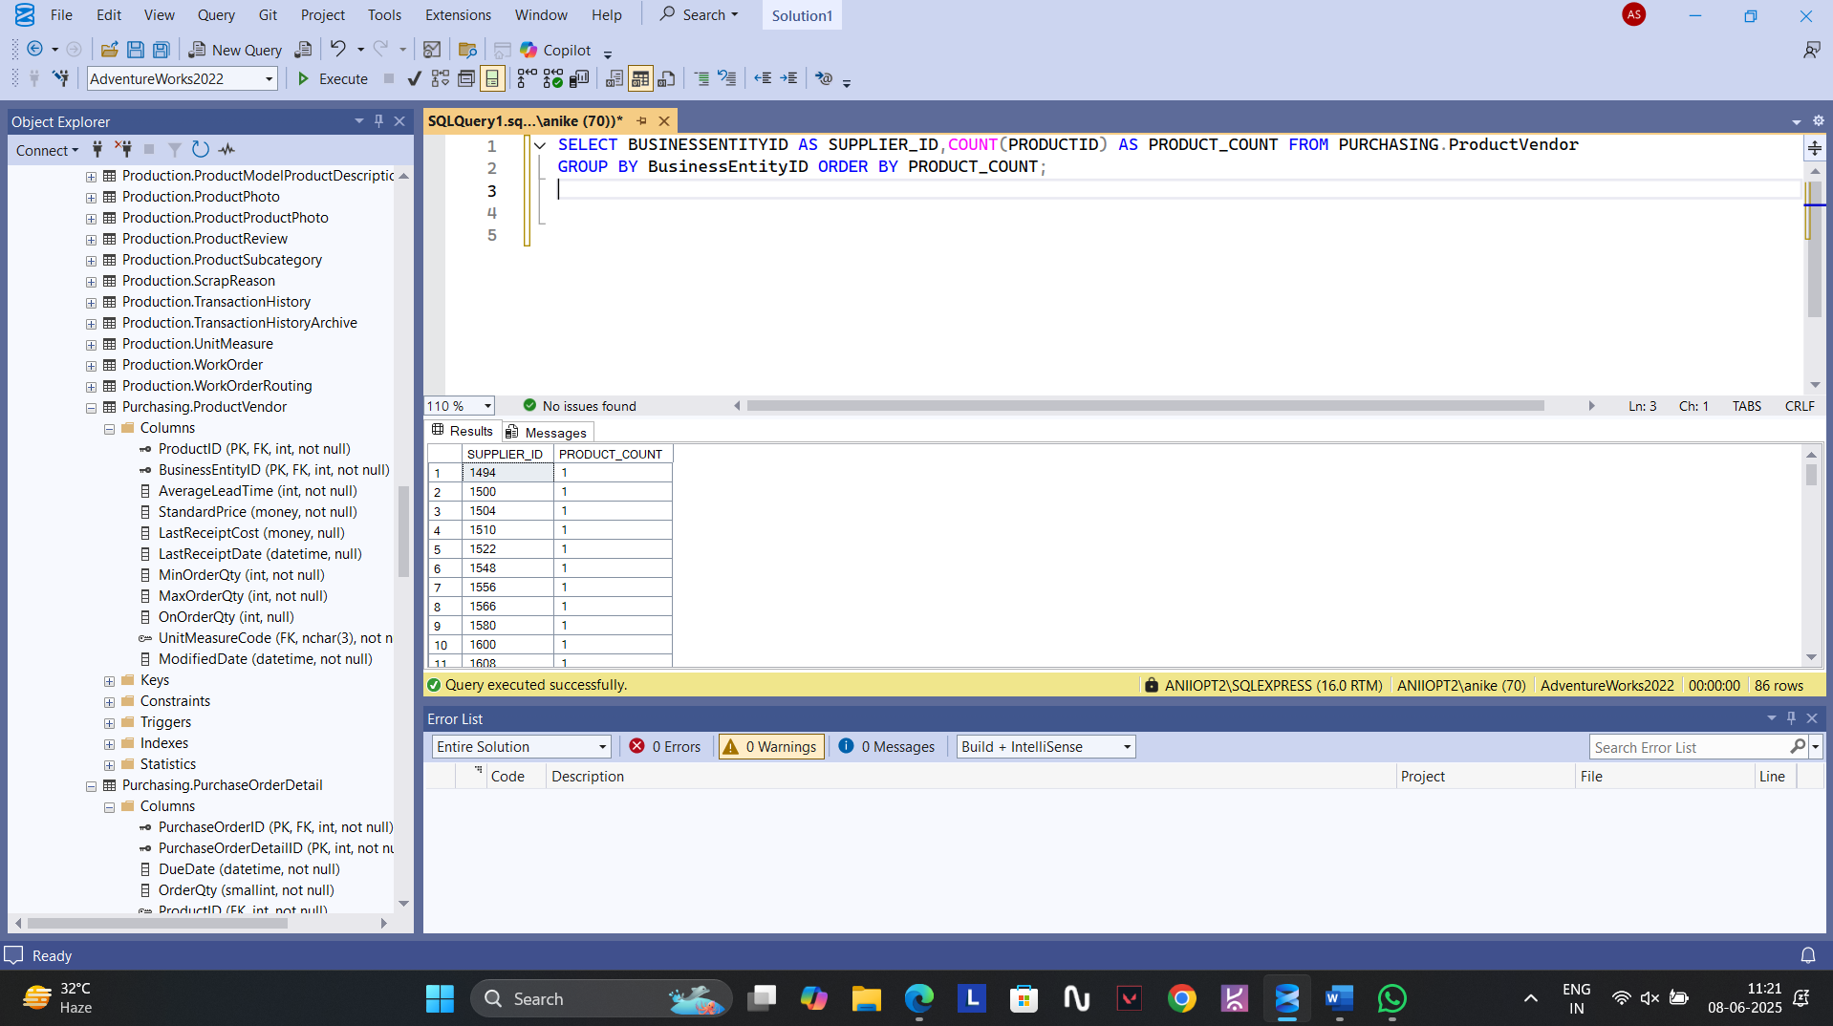

**41.** **SELECT TOP 10 C.CustomerID,P.FirstName,P.LastName,SUM(SH.TOTALDUE) AS TOTAL_SPENT_ON_ORDERS**

**FROM SALES.Customer C LEFT JOIN SALES.SalesOrderHeader SH ON C.CustomerID=SH.CustomerID JOIN PERSON.Person P**

**ON C.PersonID=P.BusinessEntityID GROUP BY C.CustomerID,P.FirstName,P.LastName ORDER BY TOTAL_SPENT_ON_ORDERS DESC;**

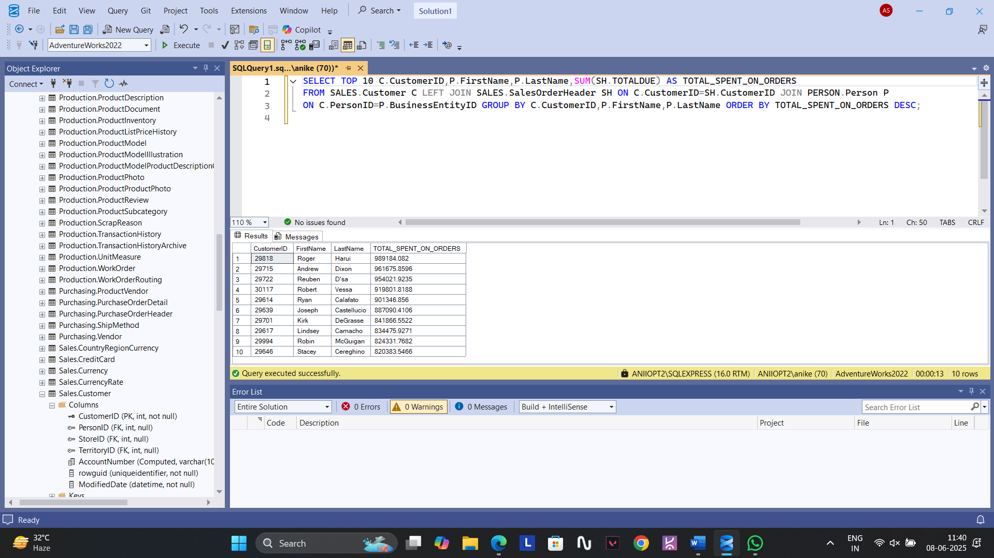

**42.** **SELECT SUM(TotalDue) AS TOTAL_COMPANY_SALES FROM SALES.SalesOrderHeader;**

